Local Safety Team Meeting Minutes

Name of Team: | MCML Local Safety Team | Chair(s): | Lewis Fausak

Date: | Jan 17, 2025 | Time: | 11:00 AM
 |  | Location: | Remotely via Zoom

LAND ACKNOWLEDGMENT:
I would like to acknowledge that UBC’s Vancouver Point Grey campus is situated on the traditional, ancestral, unceded territory of the Musqueam people. I would also like to acknowledge that you are joining us today from many places, near and far, and acknowledge the traditional owners and caretakers of those lands.

AGENDA:
- Roll Call  - Review Central Accident/Incident Reporting System (CAIRS) report of Accidents/Incidents  - Monthly Incident List & Statistical Summary Report  - Review Workplace Safety Inspections (including any changes to equipment, machinery or work processes that may affect the health or safety of workers) | - Review Education and Training  - Ongoing Business – Status of Action Items, Review of Previous Minutes  - New and Other Business  - Next Meeting  - Meeting Adjournment

- ROLL CALL
Worker Representatives | Work Location | Present | Regrets | Absent
Imelda Cheung | MCML |  | ☐ | ☐
Alan Lee | MCML |  | ☐ | ☐
Sylvia Leung | MCML |  | ☐ | ☐
Carly McGregor | MCML |  | ☐ | ☐
Lewis Fausak | MCML |  | ☐ | ☐
Thorsten Knipfer | MCML | ☐ |  | ☐
Jack Edgar | MCML | ☐ | ☐
Samuel H. |  | ☐ | ☐
Employer Representatives | Work Location | Present | Regrets | Absent
Andy Jeffries | MCML |  | ☐ | ☐
Resources/Guests | Work Location | Present | Regrets | Absent
 |  | ☐ | ☐ | ☐

Approve Previous Month’s Minutes? Yes No ☐

- REVIEW CAIRS REPORT OF ACCIDENTS/INCIDENTS:
See attached incident report:
Monthly Incident List & Statistical Summary Report (make note of trends etc. For any general CAIRS information that requires discussion or action, please record under “New Business”. Any incident specific items and follow up requests are to be listed below)
(* See Legend at end for Priority and Status Codes)
Item #  (Use CAIRS Incident ID #) | Priority | Date | Action Plan  (Actions Taken/Need to be taken) | Assigned To | Follow up: Date Pending | Status
 |  | Dec 3, 2024 | Bike to UBC Farm; dog tied to bike and dog wandered off and jerked the bike; the person fell and got injured; supervisor talked to the person and advised not to tie the dog to bike to prevent accidents |  |  | C

- REVIEW OF WORKPLACE SAFETY INSPECTIONS (including any changes to equipment, machinery or work processes that may affect the health or safety of workers)
Inspections for December: MCML 22,A,B, 34A,B,C,48C,D,G,H,320 (AJ/LF) 48A,B,202 (AL),328,332,332A (CM), 66, 180C (IC/AJ)
Inspections for January: None
Inspections for February: MCML ext, stairwell, general interior (AJ/LF), 192/194 (LF), 214/218 (IC), GH, Totem (MB)
Item #  (Use Inspection #) | Priority | Discussion/Comments/Recommendations | Assigned To | Follow up: Date Pending | Status
MCML 62  H-5 | C | Stainless shelves are not anchored to wall, which may pose falling hazards in the event of an emergency. Email lfs.facilities@ubc.ca to submit a service request to anchor shelves to wall. An email has been sent to lfsus. This space is actually assigned to Agora so will reach out to Agora. Request has been submitted on PlanOn. Shelving has to be mobile so may not need to be anchored. | LF/Agora | Jan 31, 2025 | IP
MCML 62  H-6 | C | Heavy items are placed on top shelves which can be very dangerous if fallen. Store heavier items at bottom shelves and lighter items on top shelves. An email has been sent to lfsus. This space is actually assigned to Agora so will reach out to Agora. | AJ/Agora | Jan 31, 2025 | IP
MCML 62  H-11 | C | Lack of PPE observed in the space. It’ll be worthwhile to ensure aprons, oven mitts, pot coasters and food preparation gloves are available in the space. An email has been sent to lfsus. This space is actually assigned to Agora so will reach out to Agora. | AJ/Agora | Jan 31, 2025 | IP
MCML 64  D-11 | C | Trophy and vases on top shelf pose falling hazard. Email lfs.facilities@ubc.ca to install an edge guard or lip on the top shelf to prevent items from falling. An email has been sent to lfsus. | AJ/LF | Jan 31, 2025 | IP
MCML 66  D-11 | C | Trophies are placed on top shelf, posing a falling hazard. Email lfs.facilities@ubc.ca to install an edge guard or lip to prevent items from falling. An email has been sent to lfsus. | AJ/LFSUS | Jan 31, 2025 | IP
MCML 180G  H-6 | C | Top shelves have no lips or guards to prevent heavy totes from falling. Install a cable tie type of constraints or remove heavy totes from top shelves. | AJ | Jan 31, 2025 | IP
MCML 308  M-46 | C | Chemicals not segregated by hazard class, this is an ongoing task for the lab manager and LST. This lab stores a large variety of oxidizers; they either need to be stored in a secondary container or be in a separate storage area. This will require a large amount of time and will postpone till summer 2024. IC will email Peter K to initiate the process. Peter K acknowledged the email but did not give consent for us to work in the lab. AJ will talk to Andrew Riseman about lab activity in MCML 308. PK will not return to lab activity anymore and samples should be properly disposed of. New PI will look at the chemical inventory list to determine what to keep/discard before a proper segregation by hazard class will be performed. This item will likely not complete until summer 2025. The space will be allocated to new APBI hire – inventory and equipment list has been passed to the new PI (Zalelum). The space has been recently tidied up and cleaned by LFS operations. | LF/IC | Jun 30, 2025 | IP
MCML 308  M-16 | C | 308 – heavy items stored up high; Ask PI to remove or move lower. Most items have been moved lower or removed. | LF | Jan 17, 2025 | C
MCML 308  M-33 | C | 308A, 308 – some containers missing workplace safety labels; ask PI to dispose of dated chemicals or put proper labels. | LF | Jun 30, 2025 | IP
MCML 308  M-18 | C | 308B – space is very cluttered; any old or obsolete equipment or samples should be removed. Most have been removed or disposed of. | LF | Jan 17, 2025 | C
MCML 230  M-16 | C | There is a missing door on the shelf adjacent to MCML 230F containing glassware. Put items that are lighter in that shelf and move the glassware to a cabinet with a door. IC will reorganize and store only light items on the open shelf by Jan 31, 2025. | IC | Jan 31, 2025 | IP
MCML 129  D-11 | C | Heavy items are placed on high places (above eye level) and are not secured by any means and can cause a falling objects hazard. Move heavy items onto lower levels of shelves, remove things that are no longer needed to make more available storage space, install lips or any means of securing heavy items if items cannot be moved lower. An email has been sent to room occupants. The room is in the process of getting vacated; to be occupied by a new soil hire. | IC/LF | Jan 31, 2025 | IP
MCML 140  D-11 | C | Heavy items at higher levels of the shelves (above eye level) need to be relocated to a lower area. Remove things that are no longer needed to make more available storage space, or move lighter things to higher spaces and heavier things to lower spaces. | IC/LF | Jan 31, 2025 | IP
MCML 136D  D-4 | C | There are no blinds in the space. Submit a request to install blinds. A service request has been submitted. | LF | Jan 31, 2025 | IP
MCML 190C  D-4 | C | The blinds are broken. There are no means of controlling light. Repair/replace the broken blinds. The request has been submitted. | LF | Jan 31, 2025 | IP
MCML 225  D-4 | C | The blinds are very difficult to lower and raise. There are no means of controlling light in this office. Replace the blinds | AJ/LF | Jan 31, 2025 | IP
MCML 248B  D-3 | C | There are no blinds to control the amount of light entering the room. Install blinds | AJ/LF | Jan 31, 2025 | IP
MCML 302, 329, 248  D-4 | C | There are no blinds in the lab. Install blinds. Combine in one item. | LF | Jan 31, 2025 | IP
MCML 190E  D-1 | C | Window bar is disconnected from the window. The window is unable to close or open. Repair the window bar, reconnect it to the window. Unfortunately, the window bar was no longer manufactured. Therefore, we will have to wait for decommissioned building to retrieve functional window bar for replacement. This could take some time. | AJ/LF | Jan 31, 2025 | IP
MCML 140  D-5 | C | There is a loud repeating noise coming from the air duct. Inspect the air duct to see what is causing the noise and see if it can be resolved without compromising the air duct. A request has been submitted. | AJ/LF | Jan 31, 2025 | IP
MCML 190  D-10 | C | Wooden bookshelf is not secured to the wall. Secure the bookshelf to the wall. A request has been submitted. The bookshelf is rather short and small so may not be any issue to be anchored. | LF | Jan 31, 2025 | IP
MCML 208B  D-17 | C | Not necessarily a hazard, but the user of the space requests for a vacuum. Provide the user of the space with a vacuum. Email AL to call 2-2173 for sweeping. AL will try to tell the custodian to vacuum the office floor. | AJ/LF | Jan 17, 2025 | C
MCML 239  D-7 | C | The room is very stuffy and a lack of fresh air. Open windows if possible. If not install a fan to circulate air in the room. Check exhaust fan functionality. A request has been submitted. | AJ/LF | Jan 31, 2025 | IP
MCML 248A  D-10 | C | There is a wooden cabinet that is not attached to the wall. Attach the cabinet to the wall with anchors or other means. | AJ/LF | Jan 31, 2025 | IP
MCML 254  D-10 | C | The cabinets are not attached to the wall. Attach the cabinet to the wall with anchors/hooks. LF will submit a service request to get anchored | AJ/LF | Jan 31, 2025 | IP
MCML 264, 264A  D-5 | C | There is a rattling noise coming from the air ducts. Inspect the air ducts and see if the noise can be resolved without compromising the function of the air ducts. A request has been submitted. | LF | Jan 31, 2025 | IP
MCML 333  D-11 | C | The mask on the top shelf can cause a falling object hazard. Secure the mask by nailing/anchoring it to the shelf. This is complete. | AJ/LF | Jan 17, 2025 | C
MCML 333  D-17 | C | User would like to remove carpet and if possible, install another outlet in the room. Huge cost will be incurred with both carpet removal and new outlet. This is not a safety concern and the faculty does not have money to replace at the moment. This item will close. | AJ/LF | Jan 17, 2025 | C
* GI- General Inspection

- EDUCATION AND TRAINING

Recommended items to discuss at JOHSC/LST Meeting (December/January)
Preparing for Extreme Winter Weather at UBC
As per the Snow Policy, if UBC is subject to extreme winter weather conditions, the Deputy Vice‐Chancellor of each campus or his/her delegate may decide to cancel or reschedule classes and/or curtail non-essential services. You are advised to regularly check the following website: https://www.ubc.ca/ in the event of extreme weather. Download the UBC Safe Vancouver app and turn on your push notifications to receive immediate information and updates that are impacting the entire campus — e.g. weather advisories, class cancellations, etc. The mobile safety app is available for download on the iOS/Apple Store for iPhone or Google Play Store for Android.

Facilities’ Municipal Services and Custodial Service teams provides ice prevention and snow removal services on the Vancouver Campus. Visit the website to see a map that identifies priority roads, sidewalks and pathways that crews will work towards when dealing with an ice or snow event. If you see any areas that need attention, please contact the Facilities Service Centre at 604-822-2173.

Engineering Control Survey
Safety & Risk Services is gathering information on the range and apparent condition of engineering controls available within research and teaching spaces on Point Grey campus. Starting in January, SRS Assistants will be touring lab spaces to record the location, condition and type of vented equipment – including (but not limited to) fume hoods, solvent cabinets, custom enclosures and Nederman arms connected into ducting. This will be done by visual observation and photos – there will be no interruptions to experimental work nor questions to answer. What we learn will be used to establish a record of engineering controls requiring HVAC connection, inform the triage of building level upgrades and repairs to HVAC systems supporting fume hoods and local area ventilation, and revise HVAC shutdown procedures to maximize occupant and operational safety.
We anticipate very brief (~10 min) laboratory visits. Prior to the visit, department personnel will be contacted to confirm scheduling and indicate any rooms with relevant equipment that might be overlooked. We are also asking that clear signage be posted on entry doors to any space where entry is likely to compromise the experiment due to light sensitivity.
For any questions regarding this survey, contact research.safety@ubc.ca.
UBC Alert testing on January 17 – are you in the loop?
UBC Alert will be sending out a test notification to UBC Vancouver students, faculty, and staff via a phone call and text message on Friday, January 17, 2025.

UBC Alert is the university’s mass notification system used to send alerts in urgent situations that pose an immediate safety or security risk to the community.

To ensure you are receiving notifications, make sure your mobile number is up to date on Workday.
The UBC Alert system works in tandem with UBC Safe App in Vancouver, and a push notification will also be sent through the app during the test. Download the app and turn on push notifications to receive important updates for safety and security risks.

Learn more about UBC Alert and UBC Safe App.

Bell Let’s Talk – Mental Health
January 22, 2025 is Bell Let’s Talk Day which raises funds for mental health initiatives and aims to reduce the stigma around mental illness. You can find more about this day and how you can contribute at Bell Let’s Talk.

Each year, 1 in 5 Canadians faces a personal mental health challenge. At UBC, we're dedicated to providing support. Faculty and staff can access a range of mental health resources at UBC Health and Wellbeing. For additional educational opportunities, explore our mental health-related courses at UBC Workplace Learning. Together, we can foster a healthier, more supportive community.

Informational Items

Additional 8 hours of Occupational Health and Safety (OHS) Training
All JOHSC members are entitled to an additional 8 hours of OHS training. Below are a few upcoming local and virtual conferences or seminars. Registration and costs associated will be the responsibility of your department.
- Western Conference on Safety (in-person) on April 14-15 at the Hyatt Regency Vancouver. Early bird registration ends on March 13, 2025.
- Employers’ Advisers Seminars (in-person or virtual): The Employers’ Advisers Office In-Person and Virtual Training Schedule for January-March 2025 has now been posted for registration.

Note - Just a reminder that this 8 hours of training is in addition to the regular Continuing Medical Education (CME)/Continuing Professional Development (CPD) time that you may use from your employment.

JOHSC Training
New dates have been released for JOHSC and LST training. You can register for JOHSC training here, and LST training here.
JOHSC Training |  | LST Training
Part 2a | Part 2b | Part 2a | Part 2b
January 13th  9:00am – 11:00am | January 16th  1:00pm – 3:00pm | February 18th  10:00am – 11:30am | February 20th  1:00pm – 2:30pm

WorkSafeBC Inspection Reports (IR)
There were 4 WorkSafeBC Inspection Reports received since the November co-chair email. As always, the “WSBC IR Summary” attachment provides a brief summary for the inspection reports and some discussion points to consider.

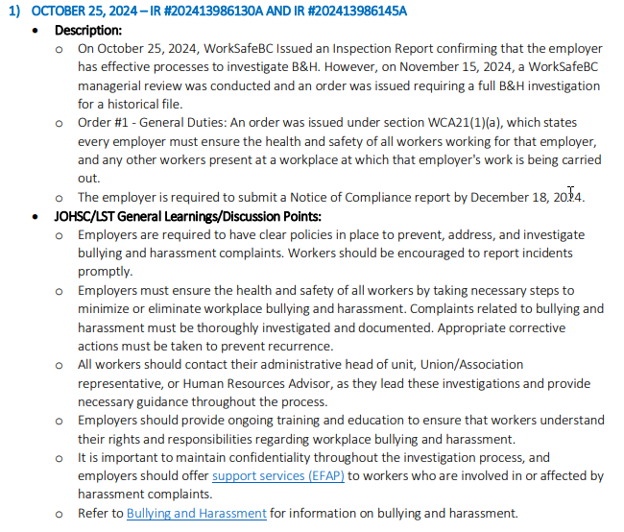
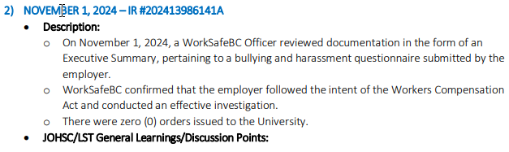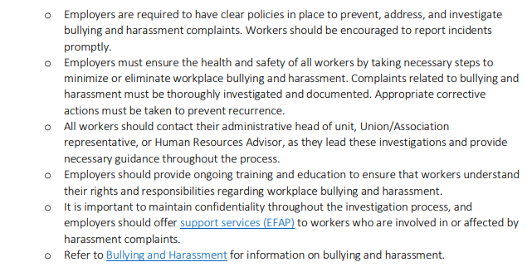
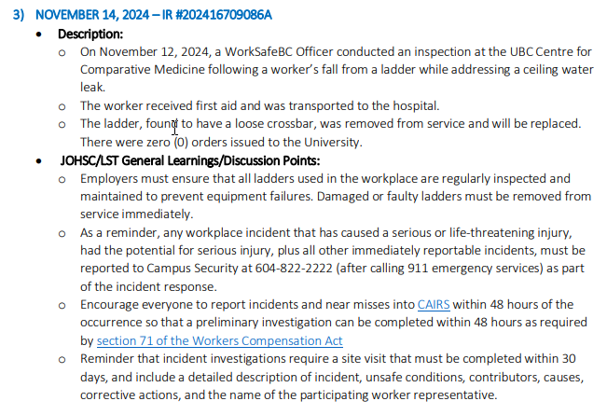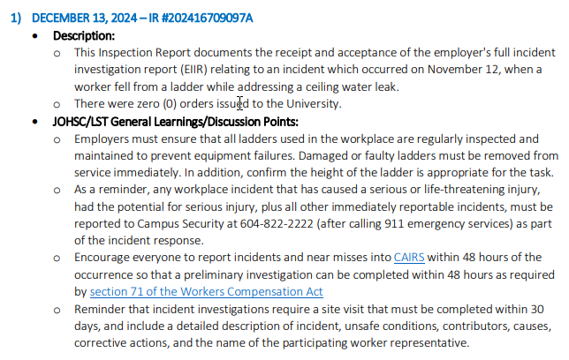
Sustainability Tips
None.

- ONGOING BUSINESS – Status of Action Items (includes review of previous meeting minutes)
Items from JOHSC / RMS or other?
Original Item # | Priority | Action Plan  (Actions Taken/Need to be taken) | Assigned To | Follow up: Date Pending | Status
180 | C | A new item was added to re-open the discussion of a LFS Safety Coordinator. The main duties should include: to perform and follow up on safety inspections; to enforce safety rules; to host training sessions so they are consistently provided throughout the faculty; to review recurrent occurrence of deficiencies during inspections so as to target specific training during group meeting. Perhaps a joint position with Forestry. Faculty currently does not have the funding available for this position although it will make a lot of sense – AJ will present the proposal to LFS core team. | AJ | Oct 31, 2024 | IP
197 | C | Review field safety report and provide a summary. The program director should be approving the protocol instead of LST. Field work safety plan reminder should be sent out in January 2025. | LF | Sept 30, 2025 | IP
202 | C | A new item has been requested to capture all issues relating to MCML 214 transition to incoming PI.  - Door signage update  - Chemical inventory update  - Plant samples and pest controls  - Personnel working in MCML 214, work duties and projects, supervisor in LFS  - Type of hazards, health and safety controls, training records  A meeting is being set up with Gurcharn and his postdocs still in LFS to discuss about plans on sending samples to Alberta and vacating lab space. AJ will meet with GB and DK on Jan 17, 2025 to get clarity. | AJ | Jan 31, 2025 | IP
203 | C | Discuss whether Friday at 11 am will still work for all LST members. Many members were absent or have left so this will be revisited in the January LST meeting. Every third Friday at 11 am remains a good option for most MCML LST members so we will keep the meeting schedule. | IC | Jan 17, 2025 | C
205 | C | Loud beeping sound was observed in the main MCML 318 area near the electrical box. Submit a request to inspect. | AJ | Jan 31, 2025 | IP
206 | C | MCML 120 got light bulbs replaced 2 months ago and left the burnt ones in the labs. In MCML 120A the light needs to be replaced and a panel was removed but no follow up has been seen. LF will submit a request. | LF | Jan 31, 2025 | IP
207 | C | Mouse poops still observed in MCML 148/144 and a big clean up will be necessary. There needs to be an organized clean up with users that frequently use the space. A meet was scheduled on Nov 25 with all users of space to discuss about arrangement. A big cleanup has been done in the space in December 2024 but a space survey has been sent. | LF/JE | Jan 31, 2025 | IP

- NEW & OTHER BUSINESS
Items from JOHSC / RMS or other?
Item # | Priority | Discussion and/or Action Items | Assigned To | Date to be Completed | Status
208 | E | At JOHSC, it was mentioned that some entrance doors in MCML have been popped open during the day. Anyone seeing that should close the door. Some individuals use small pins to avoid the doors from properly closing but not visibly open. Be aware of these and close the doors behind you. Report any suspicious activities after hours and call campus security. | LF | Jan 17, 2025 | C
209 | E | JE will be leaving UBC and beginning a new job as consultant. He will no longer serve on the LST. His replacement Kylee Smith will join MCML LST beginning February 2025. A calendar invite will be sent to Kylee for Feb 2025. | IC/LF | Jan 23, 2025 | C

- NEXT MEETING
Date: | Feb 21, 2025
Time: | 11:00 AM
Location | Remotely via Zoom or MCML 139

- MEETING ADJOURNED
Time: | 11:52 am

LEGEND

PRIORITY: |  | STATUS:
A | Critical/Life threatening/high probability | N | New
B | Urgent/moderate probability of re-occurrence | R | Repeat
C | Important/low probability of re-occurrence | C | Complete
D | Reminders | IP | In Progress
E | Information | RF | Referred forward

Send a copy of the meeting minutes report to the JOHSC. Highlight important items that must be reviewed/discussed at next JOHSC meeting.

Monthly Distribution and Posting of Approved Meeting Minutes (Required):
- All LST members
- Appropriate JOHSC
- Risk Management Service

