Local Safety Team Meeting Minutes

Name of Team: | MCML Local Safety Team | Chair(s): | Lewis Fausak

Date: | July 11, 2025 | Time: | 11:00 AM
Date: | July 11, 2025 | Location: | Remotely via Zoom

LAND ACKNOWLEDGMENT:
I would like to acknowledge that UBC’s Vancouver Point Grey campus is situated on the traditional, ancestral, unceded territory of the Musqueam people. I would also like to acknowledge that you are joining us today from many places, near and far, and acknowledge the traditional owners and caretakers of those lands.

AGENDA:
- Roll Call  - Review Central Accident/Incident Reporting System (CAIRS) report of Accidents/Incidents  - Monthly Incident List & Statistical Summary Report  - Review Workplace Safety Inspections (including any changes to equipment, machinery or work processes that may affect the health or safety of workers) | - Review Education and Training  - Ongoing Business – Status of Action Items, Review of Previous Minutes  - New and Other Business  - Next Meeting  - Meeting Adjournment

- ROLL CALL
Worker Representatives | Work Location | Present | Regrets | Absent
Imelda Cheung | MCML |  | ☐ | ☐
Sylvia Nyamaizi | MCML |  | ☐ | ☐
Sylvia Leung | MCML |  | ☐ | ☐
Carly McGregor | MCML | ☐ | ☐
Lewis Fausak | MCML |  | ☐ | ☐
Thorsten Knipfer | MCML |  | ☐ | ☐
Kylee Smith | MCML | ☐ | ☐
Employer Representatives | Work Location | Present | Regrets | Absent
Andy Jeffries | MCML |  | ☐ | ☐
Resources/Guests | Work Location | Present | Regrets | Absent
 |  | ☐ | ☐ | ☐

Approve Previous Month’s Minutes? Yes No ☐

- REVIEW CAIRS REPORT OF ACCIDENTS/INCIDENTS:
See attached incident report:
Monthly Incident List & Statistical Summary Report (make note of trends etc. For any general CAIRS information that requires discussion or action, please record under “New Business”. Any incident specific items and follow up requests are to be listed below)
(* See Legend at end for Priority and Status Codes)
Item #  (Use CAIRS Incident ID #) | Priority | Date | Action Plan  (Actions Taken/Need to be taken) | Assigned To | Follow up: Date Pending | Status

- REVIEW OF WORKPLACE SAFETY INSPECTIONS (including any changes to equipment, machinery or work processes that may affect the health or safety of workers)
Inspections for Jun: MCML 220, 230, 240 (IC)
Inspections for July: MCML Ext, stairwells, int (AJ/LF), MCML 102, 112, 118, 120 (LF)
Inspections for Aug: MCML 130, 136, 302, 308 (LF), MCML 180G (IC)
Item #  (Use Inspection #) | Priority | Discussion/Comments/Recommendations | Assigned To | Follow up: Date Pending | Status
MCML 62  H-11 | C | Lack of PPE observed in the space. It’ll be worthwhile to ensure aprons, oven mitts, pot coasters and food preparation gloves are available in the space. An email has been sent to lfsus. This space is actually assigned to Agora so will reach out to Agora. VCH inspection has noted PPE issues as well so AJ will confirm that this is addressed. | AJ/Agora | Apr 30, 2025 | IP
MCML 58, 62  D-10 | C | Heavy bottles of vinegar, soya sauce, and oil stored on top of shelves. Email LFSUS to move heavy items to lower shelves and organize them to prevent items from falling onto workers/students. | Agora | Jul 31, 2025 | N
MCML 59, 59A  H-6 | C | Chopping boards and kettles on the top of racks. Detergents and disinfectants stored on top shelves. Both can fall and injure student volunteers  . Email LFSUS/Agora to move items in high spaces below eye level and place lighter materials on higher racks and shelves. | LFSUS/Agora | Jul 31, 2025 | N
MCML 190E  D-1 | C | Window bar is disconnected from the window. The window is unable to close or open. Repair the window bar, reconnect it to the window. Unfortunately, the window bar was no longer manufactured. Therefore, we will have to wait for decommissioned building to retrieve functional window bar for replacement. This could take some time. Submit a request to get the bar adjusted. LF to re-submit the request to get it started. | AJ/LF | Jul 31, 2025 | IP
MCML 194  M-23 | B | Roller shades on the West window are not operational, this room needs properly functioning shades due to a two way mirror that enables researchers to view subjects. LF to submit a request to have roller shades fixed. The roller shades should still be under warranty by Cascadia. LF to follow up to see where this stands. | LF | Jul 31, 2025 | IP
MCML 22A  F-34 | C | Some items placed near the door make accessing the light switch difficult. Suggest to relocate these items and clear area. LF and GC tidies it up to make it accessible. | AJ/LF | Jul 11, 2025 | C
MCML 48D,H  H-20 | C | Storage areas are cluttered – suggest to clear out so that lights are accessible. 48D will be ongoing during the summer 2025 and expect to be vacated by end of August 2025. 48H is the old cold room. | AJ/IC | May 31, 2025 | IP
MCML 48A  F-34 | C | Paint shaker ball mill foam has fallen off. Not sure if we want to screw it in instead of duct taping? It might not go back in as it is mildly shredded. Look for foam panel to replace in workshop. LF found screws and nuts to secure. SN/LF/AJ will meet to look at the other large shaker to see if it will be appropriate for the research work. | AJ/LF | Jul 31, 2025 | IP
MCML 66  D-1 | C | Blinds are fully open during inspection. Email LFSUS executives to ensure blinds are closed daily upon exits to prevent potential thefts in the space due to the widely open view of the space. This will be done in conjunction with the upcoming annual inspection to the new LFSUS executive members. An email has been sent to Thilini to discuss with LFSUS. | IC | Jul 25, 2025 | C
MCML 64, 66  D-2 | C | Some items were left on the floor in the room and many boxes are stacked by the window. Email LFSUS/Agora to consider organizing the space properly with shelf/cupboard. | LFSUS/Agora | Jul 31, 2025 | N
MCML 64  D-10 | C | Glass jars, bowls and wooden boxes in Tupperware boxes are placed on storage cabinet. Trophies on top shelves can fall over. Email LFSUS/Agora to move heavy items to lower shelves or properly arranged in boxes on the floor. Organize them to prevent items from falling onto workers/students. | LFSUS/Agora | Jul 31, 2025 | N
MCML 66  D-10 | C | Trophies on top shelves near the door pose a falling hazard. Email LFSUS/Agora to move heavy items to lower areas | LFSUS/Agora | Jul 31, 2025 | N
MCML 214  M-14 | C | Biohazard wastes observed in space but space does not have a biosafety permit and door signage does not reflect biohazard level 1 work. Space is being decommissioned; biohazard materials should be properly disposed of before passing the space to another PI. | IC | Jul 31, 2025 | IP
MCML 214  M-39 | C | No biosafety permit is posted. Biosafety work should have completed but biohazardous wastes have to be properly disposed of. Consult with the new PI to see if any permit process should be initiated. Consider a PI onboarding package from the lab safety point of view including biosafety permits, Quartzy use, hazardous waste management, etc. | IC | Jul 31, 2025 | IP
MCML 218  M-16 | C | Two metal shelving by wall are not anchored. Zip-tied the two shelving together so as to reduce chance of shelves tipping over.  The large shelving is fully packed with materials and some boxes contain glassware on top shelf. Recommend to move heavy and glassware boxes to lower shelves to prevent falling hazard. The space is in the process of reorganization so hopefully some of these issues will be addressed soon. | LF/AJ | Jul 31, 2025 | IP
MCML 218  M-24 | C | Many totes are stacked 5 boxes high; they’re quite stable and not difficult to fall. Best to only stack 3 boxes high; the samples are being arranged to be shipped out so the issues may resolve soon. Majority of the totes have been emptied and contents trashed. Remaining totes will be shipped out by end of June 2025. Gurcharn needs to get those samples sent. | LF/AJ | Jul 31, 2025 | IP
MCML 48C  H-1 | C | Wood planks and other items are not stacked appropriately. Miscellaneous items are just on top of each other and unorganized. Email Zoran and Andy B to tidy up the room and organize miscellaneous items. An email has been sent to Zoran. | ZN/AB | Jul 31, 2025 | C
MCML 48C  H-5/H-6 | C | Heavy items are stacked on top of shelves. No edge guards present on shelves. Email Zoran and Andy B to remove heavy items stacked on top of shelves and install edge guards. An email has been sent to Zoran. | ZN/AB | Jul 31, 2025 | C
MCML 48C  H-20 | C | Many loose and unsecured items, i.e. beams and wooden planks leaning against tables. The room must be tidied for improved accessibility. Email Zoran and Andy B to tidy up the room and organize miscellaneous items and to ensure that items are organized in a way that they are securely fastened and may not fall on people upon entry of space. An email has been sent to Zoran. | ZN/AB | Jul 31, 2025 | C
MCML 48F  D-10 | C | Heavy stereo and speakers placed high up on a shelf. Email AJ to lower the stereo from the shelf. | AJ | Jul 31, 2025 | N
MCML 48G  H-1 | C | Items are not stacked properly, i.e. items appear to be hanging off each other. Room must be tidied and reorganized such that boxes are not hanging off shelves. 48G has been tidied up; masks were relocated to 240A. | IC/AJ/GC | Jul 25, 2025 | C
MCML 48G  H-5, H-6 | C | Boxes are hanging off shelves and there are no edge guards present. There are wooden boards on top of the shelves that are not secured and may fall. Room must be tidied up and reorganized such that boxes are not hanging off shelves. Edge guards should be installed. Wooden boards may need to move lower. Items not necessary should be removed to free up space. 48G has been tidied up; masks were relocated to 240A. | IC/AJ/GC | Jul 25, 2025 | C
MCML 131  D-1 | C | Blinds were left open. Email AF to remind about closing windows and blinds at the end of day to prevent potential thefts. An email has been sent to Andrea. | AF/IC | Jul 31, 2025 | C
MCML 170C  D-10 | C | Heavy items are stored on top of shelves in MCML 170C. Email room occupants to recommend them to lower the heavy item and store it closer to the ground. | IC | Jul 31, 2025 | N
MCML 170B,C, D-10 | C | Heavy items stored high, risk of falling. Email room occupants to lower items, make space to store them, and reorganize room to accommodate for items – if possible | IC/LF/GC | Jul 31, 2025 | N
MCML 170B  D-2, D-12 | C | Room is cluttered, makes the room inaccessible and poses a tripping hazard. Tidy and reorganize rooms. | IC/GC | Jul 31, 2025 | N
MCML 102C, 118A  D-10 | C | Books and miscellaneous items (i.e. glass containers and mugs) on top of shelves present falling hazards. Email Fernanda to move heavy items to lower shelves or on the floor and organize them to prevent items from falling onto workers/students. *double check lips exist to prevent falling | IC/LF | Jul 31, 2025 | N
MCML 127  D-10 | C | Lots of paperwork, books and folders are on top shelves. Email room occupants to place heavy items in lower shelves if possible. | LF/IC | Jul 31, 2025 | C
MCML 136D, 137  D-2 | C | General clutter observed in offices and corner spaces are used as storage of posters and other research materials. The room becomes less accessible and increases risk of tripping. Email occupants to tidy up and remove any garbage from the office. | ZN, LF, IC, AJ | Aug 31, 2025 | N
MCML 136D, 137  D-10 | C | Heavy items placed on top rack of shelves and on top of filing cabinets. Email room occupants to lower heavy items and reorganize storage. Remove unnecessary items that are still in the room. | ZN, LF, AJ, IC | Jul 31, 2025 | N
MCML 136D  D-9 | C | Few cabinets and bookcases are free standing in the middle of the room. Email graduate students in space to rearrange cabinets and bookcases near the walls of the room so they can be anchored. | AJ/LF/IC | Jul 31, 2025 | N
MCML 189  D-10 | C | Heavy items on top of shelves. Email Dan Weary to lower heavy items from the top of shelves and accommodate for the items on the ground or on lower shelves. An email has been sent to Dan Weary. | DW/IC | Jul 31, 2025 | C
MCML 180C,D  D-10 | C | Heavy items on top of shelves in the room. Contact office occupants (Amelia MacRae in room 180C) and inform them to lower their items  . An email has been sent to Katia. | LF/IC/GC | Jul 31, 2025 | C
MCML 180G  D-16 | C | Soil samples in coolers and tubs are obstructing the way in the cooler. Email Sean Smukler, or Jessica.leigh@ubc.ca to move the samples onto the shelf such that they don’t obstruct the way. | LF/IC/GC | Jul 31, 2025 | N
MCML 190B,C  D-10 | C | Glass is high up on shelf. Email Katia to lower the glass from the shelf. Reorganize the room such that the glass can be stored at a lower level. An email has been sent to Katia. | IC/LF/GC | Jul 31, 2025 | C
MCML 214A,B  D-2 | C | Office space could be tidied and cleaned, the room was cluttered upon inspection; reach out to the room occupants and advise them to tidy the room. (Paul R) | IC/LF | Jul 31, 2025 | N
MCML 218A  D-10 | C | Heavy items stored high, on top of shelves; contact room occupants and ask them to lower the items. Also, to reorganize their space to ensure that it is safe to store on a lower level. An email has been sent to Mehrdad. | IC/LF | Jul 31, 2025 | C
MCML 262,  D-2 | C | Room tidiness is inadequate. Room 262: Paper scraps are dumped in the right corner of the room. Implement signage for staff to recycle or dispose of their paper appropriately. | IC/LF | Jul 31, 2025 | N
MCML 264A, 266, 268A  D-2 | C | Room tidiness is inadequate. Room 264A, 266, 268A: Cables can be wrapped or taped to prevent any tripping. Video equipment can be rearranged in the room such that it takes up less space (i.e. folded up or positioned upright). Follow up with room occupants in regards to keeping the room tidy and ensuring the space is hazard free. An email has been sent to LC. | IC/LF | Jul 31, 2025 | C
MCML 323  D-10 | C | Heavy items are placed up high. Advise the room occupant to items from high areas to low areas. An email has been sent to Andrew Riseman. | IC/LF | Jul 31, 2025 | C
MCML 218  M-28 | C | Ergonomic posters are not found. Put up few posters to encourage users to pay attention to ergonomics. | IC | Jul 8, 2025 | C
MCML 48C,D, 56, 58, 59, 59A, 60  H-15/H-17 | C | Emergency contact numbers and ergonomic procedures must be posted in the common areas of the basement  . Post relevant information sheets on walls in the common areas of the basement  . | IC/GC | Jul 8, 2025 | C
MCML 48F  D-11 | C | Common areas near room do not have the emergency contact list. Post relevant contact information in MCML basement. | IC/GC | Jul 8, 2025 | C
MCML 48G  H-8, H-9, H-10 | C | Disinfectant stored in the room is flammable and has no available SDS. Relocate the disinfectant to MCML 230D and add them to Quartzy for accurate record and SDS access. | IC/GC | Jul 8, 2025 | C
MCML 60, 124  D-11 | C | Common areas near room do not have the emergency contact list. Post relevant contact information in MCML basement. | IC/GC | Jul 8, 2025 | C
MCML 48G, 62, 64, 66, 102C, 112A  D-11, D-13 | C | Missing ergonomic and emergency contact poster. Post emergency contact and ergonomic information poster. | IC/GC | Jul 8, 2025 | C
MCML 154, 166  E-1 | C | No emergency contact list information. Post the emergency contact list posters in a visible location of the room. | IC/GC | Jul 8, 2025 | C
MCML 180  D-13 | C | No ergonomic information in the office. Post an ergonomic poster in a visible area of the room. | IC/GC | Jul 8, 2025 | C
MCML 220  M-37 | C | Biological Safety Reference is outdated (Jan 2012); Generate a QR code for the new Biological Safety Manual and make a poster for it. Use this link to generate a QR code: UBC Biosafety User Reference Manual. | IC | Jul 8, 2025 | C
MCML 230  M-37 | C | Biosafety manual is outdated (2012) and can be updated. Generate a QR code for the new biosafety manual using the following link: UBC Biosafety User Reference Manual  - Make a poster from the QR code | IC | Jul 8, 2025 | C
MCML 230  M-13 | C | No “No Smoking” signs present in the room. Put a “No Smoking Sign” besides the “No Food or Drinks” Sign. | IC | Jul 8, 2025 | C
MCML 249  D-11 | C | Lack of emergency contact information by the room. Post the emergency contact information poster on the door/in the room/ in a nearby hallway. | IC | Jul 8, 2025 | C
MCML 344, 348  D-11 | C | Lack of emergency contacts by the room. Post emergency contact information on the door/in the room/ in a nearby hallway. | IC | Jul 8, 2025 | C
MCML 344, 352  D-13 | C | Lack of ergonomic posters by the room. Post the ergonomic information on the door/ in the room/ in a nearby hallway. | IC | Jul 8, 2025 | C
MCML 58, 62  D-3 | C | 2 lights are out in the room. Submit a service request to fix the lights. | LF | Jul 10, 2025 | C
MCML 60  D-3 | C | 1 Ceiling light near TV is out; 1 Ceiling light outside room 66 is dead. Submit a service request to fix the lights. | LF | Jul 10, 2025 | C
MCML 102C, 112A, 118A  D-3 | C | 1 Light Panel out. Submit a service request to replace the lights. | LF | Jul 10, 2025 | C
MCML 140, 185 | C | Lights are not reliable and do not work well. Submit a service request to fix lights. | LF | Jul 10, 2025 | C
MCML 170  D-3 | C | 1 Light flickering in the room according to occupants, needs to be replaced. Submit a service request to replace light. | LF | Jul 10, 2025 | C
MCML 202  D-3 | C | 2 lights out; submit a service request to replace bulb. | LF | Jul 10, 2025 | C
MCML 270C, 278C  D-3 | C | Room 270C: 3 Lights are burnt out  Room 278C: Lights are flickering the room – must be changed to new light bulbs.  Submit a maintenance/service request to replace the lights | LF | Jul 10, 2025 | C
MCML 318J  D-3 | C | 8 Lights burnt out in the room. Submit a maintenance/ service request to replace the lights. | LF | Jul 10, 2025 | C
MCML 360D  D-3 | C | 1 Light burnt out in the room. Submit a maintenance/ service request to replace the lights. | LF | Jul 10, 2025 | C
MCML 321  D-3 | C | 2 lights burnt out in the room. Submit a maintenance/ service request to replace the lights. | LF | Jul 10, 2025 | C
MCML 60  D-16 | C | Elevator at the bottom level is missing a button cap. Submit a service request to repair and install a new button cap for the elevator. A request has been submitted on Jul 10, 2025. | LF | Jul 31, 2025 | N
MCML 148, 170  C, 181, 183  D-1 | C | Blinds in rooms 148, 170C, 181, 183 are old and must be replaced. Submit service request to replace blinds. | LF | Jul 31, 2025 | N
MCML 131  D-1, D-4 | C | Blinds are old and occupants are not closing them at the end of the day. Submit a service request to repair/replace blinds and email occupants to close windows and blinds at the end of day. | LF/IC | Jul 31, 2025 | N
MCML 148  D-4 | C | Blinds are old and creaky by the window. Submit a service request to repair/replace blinds. | LF | Jul 31, 2025 | N
MCML 181, 183, 189  D-1 | C | Blinds are old and cannot be pulled down. Submit a service request to get it replaced/repaired. | LF | Jul 31, 2025 | N
MCML 170C, 180F, 193  D-4 | C | Blinds are old and difficult to pull down. Submit a service request to replace blinds in the room. | LF | Jul 31, 2025 | N
MCML 225, 231, 239  D-4 | C | Blinds are old and cannot be brought down; submit a request to replace the blinds in the room with newer blinds that can be easily drawn down. | LF | Jul 31, 2025 | N
MCML 325,327,333,336  D-4 | C | Blinds cannot be drawn down and are not working properly. Install new blinds that can be drawn down easily in the rooms. | LF | Jul 31, 2025 | N
MCML 329  D-4 | C | There are no blinds for the windows. Install new blinds that can be drawn down easily in the rooms. | LF | Jul 31, 2025 | N
MCML 339,341  D-4 | C | Blinds are old and cannot be drawn down. Replace the blinds and install newer ones that can be drawn down the windows easily. | LF | Jul 31, 2025 | N
MCML 102C, 118A  D-9 | C | Wooden bookcases not secured to the wall. Submit a service request to anchor the wooden bookcase or to replace the bookcase itself. | IC/LF | Jul 31, 2025 | N
MCML 135  D-16 | C | A wooden piece from the upper wall has fallen partly. Risk of the wooden piece falling and injuring staff. Submit a service request to fix wall and wooden piece ASAP. A request has been submitted on Jul 10, 2025. | LF | Jul 31, 2025 | N
MCML 160  E-11 | C | 2 Windows in the room have missing latches. Submit a service request to replace/ repair the windows. A request has been submitted on Jul 10, 2025. | LF | Jul 31, 2025 | N
MCML 194  D-16 | C | Door inside animal observation lab has an unusual swing speed, a black out panel is also required in the room  . Check the door hinges, replace any old screws or parts as necessary  . AJ/LF has done the fixes and the problem is resolved. | AJ/LF | Jul 10, 2025 | C
MCML 191, 193  D-16 | C | Corkboard and chalkboards need to be installed in rooms as they may fall over (currently just leaning against the wall). Install corkboards and chalkboards into the office and ensure they are adequate height off the ground  . | AJ/LF | Jul 31, 2025 | N
MCML 229  D-16 | C | Water leak in the room – could cause electrical damage, mold growth or slipping hazard; submit a service request to repair water leak. Post signage around the leak to prevent tripping. *IC will check again** | IC/LF | Jul 31, 2025 | N
MCML 221, 230C  D-16 | C | Whiteboards are not anchored to wall; they may pose falling hazard. Submit a request to install whiteboards. | IC/LF | Jul 31, 2025 | N
MCML 208  D-16 | C | Part of ceiling is hanging and poses a falling hazard. Submit a request to get it fixed. A request has been submitted on Jul 10, 2025 | LF | Jul 31, 2025 | N
MCML 227  D-16 | C | Windows are dirty and need to be washed; Follow up with a maintenance/service request for window cleaning. Unfortunately MCML is not due for window cleaning until 2026/2027 and with a big seismic project coming summer 2026, it’ll likely mean 2027/2028. Email MK the bad news. An email has been sent to Maja. | LF | Jul 31, 2025 | C
MCML 248, 248A, 248B, 248C  D-16 | C | Room 248 & 248A-C:  - Carpet has not been cleaned before. Room occupants are requesting a carpet steam clean  - There is a lack of proper signage (of room numbers) for the office doors in 248  Organize a carpet steam cleaning for the listed offices – if possible  Install room numbers for the offices that are missing signage  AJ will discuss with BH since it will require all desks/chairs to be removed from room to get things started. | AJ/LF | Jul 31, 2025 | N
MCML 270A  D-16 | C | Carpet has not been cleaned before. Room occupants are requesting a carpet cleaning. Organize a carpet steam cleaning for the listed offices – if possible. | LF | Jul 31, 2025 | N
MCML 256  E-11 | C | Left most window in the classroom has a broken window (check the latch). Submit a maintenance/service request to get the window fixed. Keep the window shut in the meantime. A request has been submitted on Jul 10, 2025. | LF | Jul 31, 2025 | N
MCML 321  D-9 | C | Book shelves and wood panels are not secured in the room. Submit a maintenance/ service request to secure the panels and book shelves to the wall. | LF | Jul 31, 2025 | N
MCML 341  D-16 | C | Squeaky door / door hinges. Follow up with maintenance to see how the door can be fixed. | LF | Jul 31, 2025 | N
MCML 348  D-16 | C | Squeaky door sweep (mechanical issues with door sweep). Follow up with a maintenance request to see how the doors can be fixed. | LF | Jul 31, 2025 | N
MCML 183  D-13 | C | Offices chairs in room 183 need to be replaced to help prevent any ergonomic issues. Look for a suitable chair for replacement. | AJ/LF | Jul 31, 2025 | N
MCML 185  D-13 | C | Chairs are beat up and old, may cause ergonomic issues. Replace old chairs if budget allows. | AJ/LF | Jul 31, 2025 | N
MCML 202  D-13 | C | Chairs in the room are old and need to be replaced; these may cause ergonomic injuries. Replace old chairs to provide ergonomic support. | IC/LF | Jul 31, 2025 | N
MCML 339  D-16 | C | Old, worn out chair – potential ergonomic issues. Provide a new chair with improved ergonomic function. | AJ/LF | Jul 31, 2025 | N
MCML 220  M-18 | C | Old cardboard and Styrofoam boxes (on top of shelves on the back left corner of the room), as well as purple chair boxes are cluttering the room; recycle or repurpose the cardboard to remove it from the space. | IC | Jul 31, 2025 | N
MCML 220  M-34 | C | Gram-stain bottles are stored in the open, on top of a counter – more prone to spill and countertop accidents; provide a secondary container for Gram-stain bottles to allow containment of any spills. Stain bottles are now consolidated in 2 plastic containers to prevent potential spillage. | IC | Jul 9, 2025 | C
MCML 220A  M-18 | C | Sink at the back of the room is dirty and needs cleaning. Light blue colored grime in the sink. Equipment on the bench top needs to be reorganized. Empty glass jugs tucked below counter top, on the floor; clean the sink while wearing appropriate PPE, remove any waste from the room (glass waste, etc.). | IC | Jul 31, 2025 | N
MCML 220B  M-18 | C | Items on top of the brown cabinet and gray locker are tidied and are cluttered. They are stacked on top of each other and not secured. Some items in the clutter includes larvae immersed in liquid – may be necessary to store these in a secondary container and on a lower level in the room. Left corner of the room is cluttered with garbage. Black counter top in the room needs tidying. Contact the room occupants and have them tidy and reorganize items in the room. An email has been sent to Yasmin. | IC | Jul 31, 2025 | C
MCML 220B  M-14 | C | Room does not have any indication of biohazardous material; follow up with SRS regarding the storage of insect samples and whether the room requires Biohazardous signage. | IC | Jul 31, 2025 | N
MCML 220C  M-18 | C | Cardboard clutter stored below a bench in the room; recycle/repurpose cardboard in the room. | IC | Jul 31, 2025 | N
MCML 220D  M-18 | C | General area is cluttered. Reorganize items and free up space to tidy the room – to free up aisle/general area. | IC | Jul 31, 2025 | N
MCML 220D  M-32 | C | Gas cylinder is close to the door. Remove the gas cylinder from the room, if possible – follow up to see if any action can be taken to move the gas cylinder. | IC | Jul 31, 2025 | N
MCML 220D  M-36 | C | Expired chemicals in shelves and in the flammable cabinet. Safely dispose of the chemicals through HWIS once permission obtained from Eduardo Jovel. Chemicals on shelves were from Gurcharn’s group and were properly disposed of through HWIS. The remaining chemical bottles will be labelled EJ and consolidated in MCML 230D. | IC | Jul 31, 2025 | N
MCML 230  M-18 | C | Dry glassware and equipment present around sink. Bench tops with lab instruments (i.e. Colorimeter, Incubator Shaker, Viscometer) can be wiped down. Put away the glassware and free equipment, wipe down bench tops. | IC | Jul 31, 2025 | N
MCML 230  M-16 | C | Back shelf (by shelf D), has no door cover. Ensure that no heavy items are stored on the top shelf – if so, move them to the lower shelf. Only filter papers of minimal weights are stored on these open shelves so they should not pose any falling hazard anymore. | IC | Jul 9, 2025 | C
MCML 230F  M-10 | C | Aisle space is limited due to loaded carts and tubs on the floor. Reorganize the room and item storage to permit for more available space (and improve tidiness). At the time of inspection 3 carts were stored in the room, limiting space. One cart has since been vacated and moved out to the general space of MCML 230. One cart is parked by the inner wall to allow for additional storage space for lab preparation. The other cart is meant to be mobile containing essentials supplies and tools to facilitate lab preparation – this cart can be moved out of MCML 230F whenever needed. The space should now no longer pose any space issue. | IC | Jul 9, 2025 | C
MCML 230F  M-18 | C | Bench tops are full while space is available in shelves to store items. Reorganize the room and item storage to permit for more available space (and improve tidiness). Currently benchtops are full due to the pipetteman maintenance work being done. Once they’re complete, the bench space will be vacated and pipetteman stored in the appropriate cupboards. | IC | Jul 9, 2025 | C
* GI- General Inspection

- EDUCATION AND TRAINING

Recommended items to discuss at JOHSC/LST Meeting (June/July)
Safety Day
A Safety Day specific email will be sent out early next week to all co-chairs so be on a lookout for that. The email will include full details about the event including the agenda for the day and how to register.

Safety Day 2025 – Save the Date – Wednesday, October 8, 2025
We are delighted to announce that Safety Day 2025 has been scheduled for Wednesday, October 8th. Building on the overwhelming positive response from our previous events, we have secured the spacious Great Hall in the AMS Student Nest as our venue. We are looking forward to hosting another exciting day with speakers, vendors, food, prizes, and more. Details below:

When: Wednesday, October 8, 2025, 8:00am – 3:30pm
Where: Great Hall (2nd floor, AMS Student Nest Building), 6133 University Blvd

Registration
Safety Day Registration is now open and can be accessed here: Register for Safety Day 2025

You are required to register for this in-person event (zoom is not available). We are limiting registration to 250 people so please register early to ensure you don’t miss Safety Day 2025. Registration will close on Sept 12, 2025. After this date, if you have any questions, would like to cancel your registration or add your name to the waitlist please email safety.risk@ubc.ca

Safety Day Webpage
The Safety Day Webpage has information on registration, agenda, speakers and getting to the venue for this special event.

Safety Day Awards
This is a friendly reminder to submit your committee’s nominations for the Safety Achievement Award by July 11, 2025.

If your committee has demonstrated exceptional dedication in promoting a safety culture, implemented effective safety initiatives, or introduced innovative ideas that addressed health and safety concerns, we encourage you to submit a nomination. This is a valuable opportunity to highlight and celebrate the collective commitment of your committee in fostering a culture of safety and care within UBC.

No achievement is too small! Please submit your committee’s nomination using the following link: Safety Day 2025 Award Nominations.

To help inspire your submissions, we’ve included examples of submissions from the previous years below:
- Increasing Ergonomics Awareness such as hosting information sessions about how to adjust your office furniture and more
- Distribution of quarterly posters outlining the committees work, membership and initiatives to workers across campuses doing similar work
- Identified a safety concern with the emergency eyewash pressure and temperature, worked with Building Ops to test and identify root cause.
- Collated safety information regarding emergency plans, exits, designated meeting areas and more into a central repository for all buildings on campus the department’s personnel must work in.

After nominations are closed, SRS will present the nominations for YOU (JOHSC/LST members) to vote on to select the winners. This will be sent out in the August co-chair email. We look forward to your nominations!

The deadline for submitting nominations for the Safety Achievement Award has been extended to Monday, July 21st . This extension is due to a low number of responses.

We know that many committees across UBC are doing meaningful work to support and promote safety. Whether your efforts are large or small, we encourage you to take this opportunity to share the work your committee has done. No action is too small, and this is a chance to highlight your impact.

With fewer nominations submitted so far, the chances of winning are higher than usual!

Submit your nomination here: Safety Day 2025 Award Nominations.

Emergency Management - Earthquake and Emergency Preparedness Workshop
Join a free personal emergency preparedness workshop designed specifically for the UBC campus community, hosted by Jackie Kloosterboer – Disaster Preparedness and Emergency Support Services Specialist.

Around the world, communities have experienced major emergencies with serious impacts. Here in Vancouver, we are at risk of significant emergencies, including large earthquakes. This online workshop will introduce simple steps you can take now to stay safe, prepare your space, and respond effectively in an emergency.

Learn how a few practical actions today can help protect you and your community tomorrow.

Workshop schedule:
Faculty and Staff
- June 13, 12:00–1:30 pm (online) Register for this workshop

For further information and additional sessions, visit SRS Emergency Preparedness

Weather and Thermal Stress Safety
UBC has taken steps to plan for extreme heat events. Given the high temperatures, we wanted to provide some resources and information to help you and your loved ones stay cool and safe.
The following air-conditioned UBC buildings are open to the public:
- Irving K. Barber Learning Centre (Monday-Sunday, 6:00 a.m. to 12:00 a.m.)
- Koerner Library (Monday-Thursday, 7:30 a.m. to 8:00 p.m.; Friday, 7:30 a.m. to 5:00 p.m.; Saturday and Sunday, closed)
Visit the Weather and Thermal Stress Safety page for the most updated information about UBC’s on-campus cooling centres.

Informational Items

Delta Branded Gas Valve Recall
UBC Facilities team is conducting a review in response to a manufacturer-issued recall for certain models of Delta-branded gas ball valves installed in labs at UBC. The manufacturer is voluntarily recalling certain models between 2006-2025 as small leaks may occur due to small cracks in a valve component, posing a fire and burn hazard. Potential leaks only occur when the valve is open, and not when the valve is closed.
Facilities Managers have recently sent out an email notice on May 15 to ask Building Administrators with lab spaces in their building to coordinate with their lab managers to identify all Delta-branded gas ball valves and contact their Facilities Manager. The Facilities Manager will then arrange a visit to the lab with the Facilities team to review and confirm whether the valves fall within the affected series.
This is a precautionary step to ensure continued safety and compliance. Please note that not all Delta-branded models are affected, however, we would like to conduct a thorough review to confirm. For more information about the recall notice, please visit the Masco website.
If you would like confirmation that this communication has been received in your building, please reach out to your Building Administrator or Lab Manager. For any questions or if you need assistance, please contact your Facilities Manager.

JOHSC Training
Currently, there are no sessions scheduled for Part 2 of either the JOHSC or LST training.

You can register for JOHSC training part 1 here, and LST training part 1 here.

WorkSafeBC Inspection Reports (IR)
There were 4 WorkSafeBC Inspection Reports received since the May co-chair email. As always, the “WSBC IR Summary” attachment provides a brief summary for the inspection reports and some discussion points to consider.
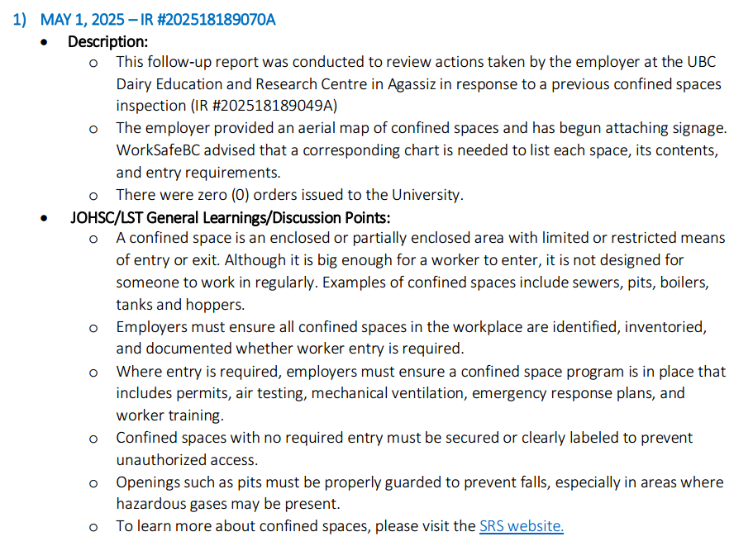

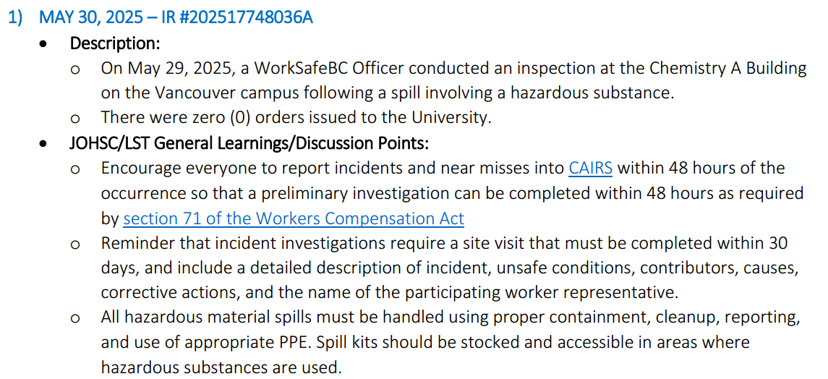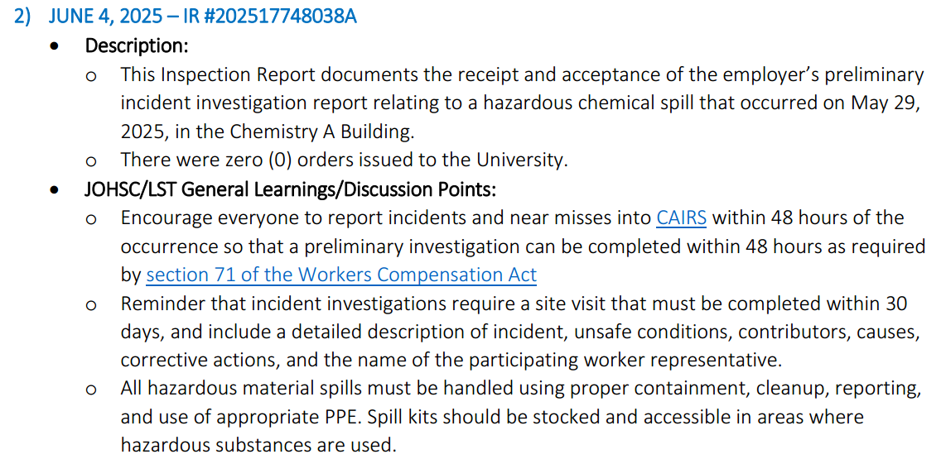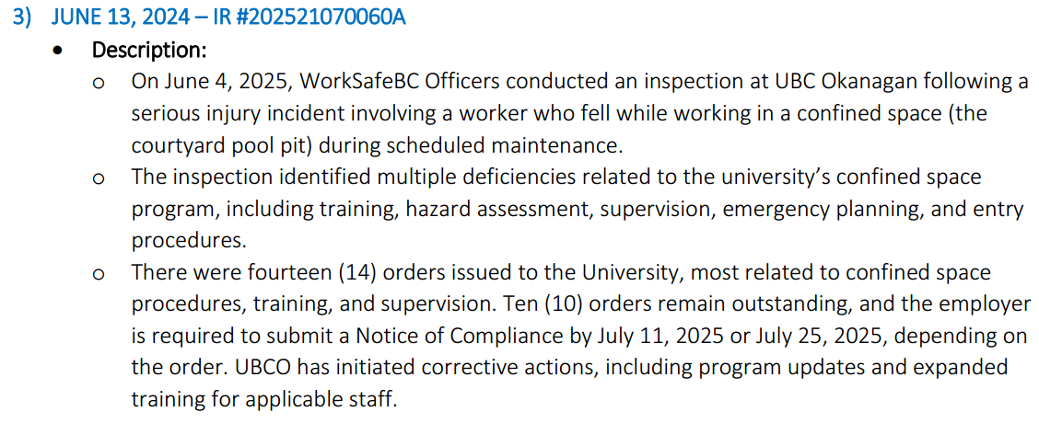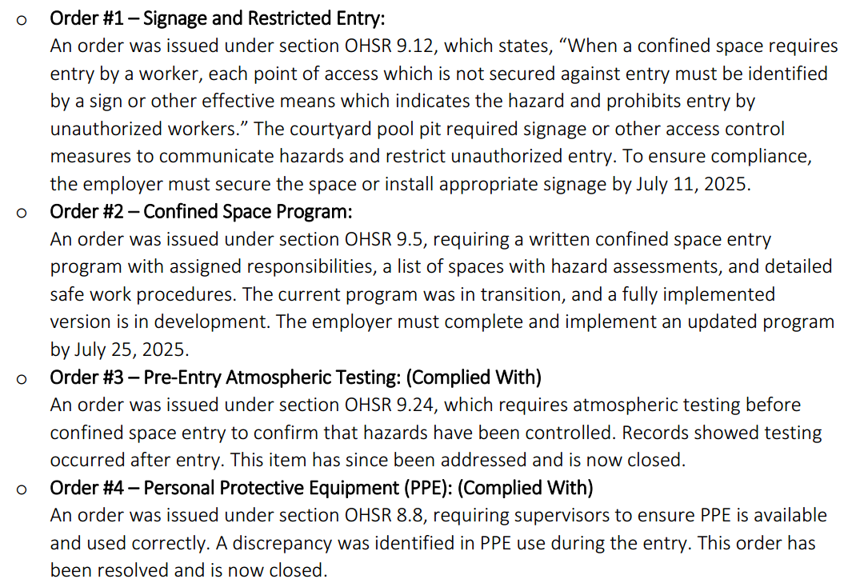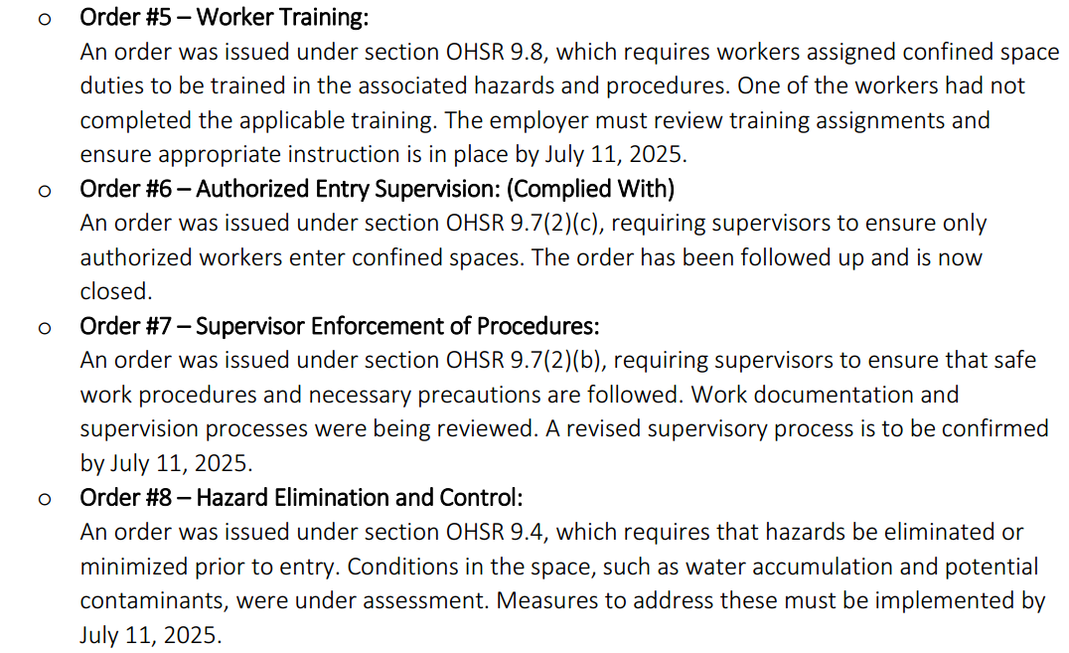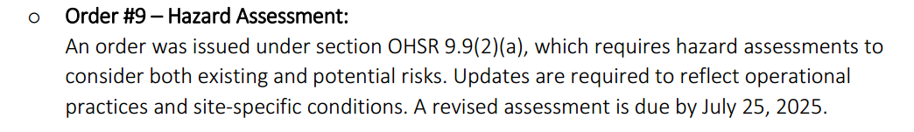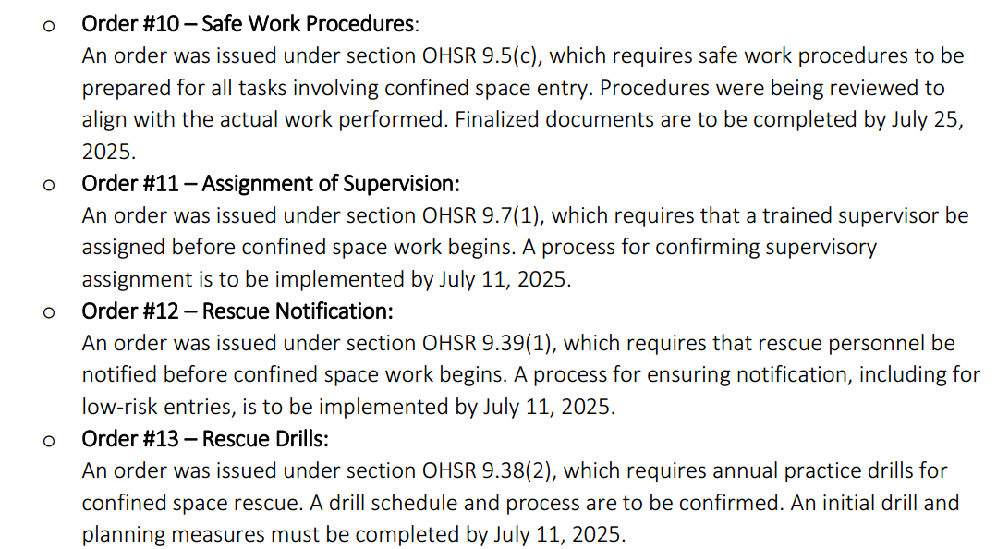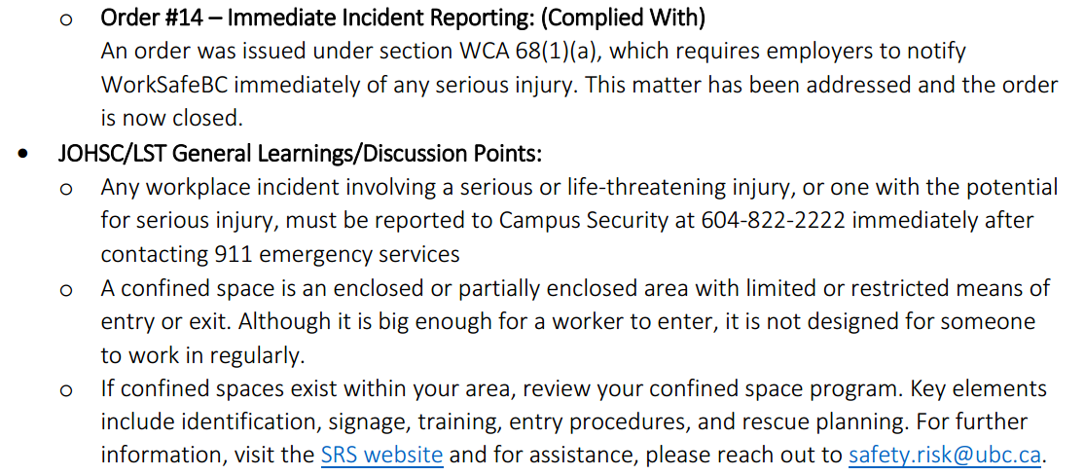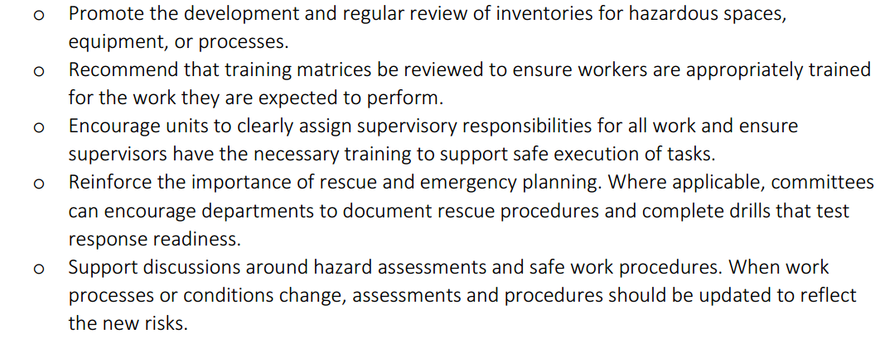
Sustainability Tips
#HowToGreenLab tip
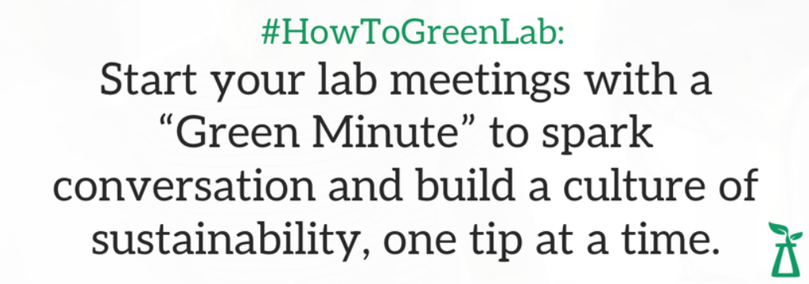

- ONGOING BUSINESS – Status of Action Items (includes review of previous meeting minutes)
Items from JOHSC / RMS or other?
Original Item # | Priority | Action Plan  (Actions Taken/Need to be taken) | Assigned To | Follow up: Date Pending | Status
197 | C | Review field safety report and provide a summary. The program director should be approving the protocol instead of LST. Field work safety plan reminder should be sent out in January 2025. LF will send out the notifications faculty-wide. The approval by program director has been turned down within LFS so PI should work with each other to come up with the plan. Since posting in LFS Today, more safety plans have been submitted for review. | LF | Jul 11, 2025 | C
214 | C | Update MCML BERP for review. MCML BERP has been updated and posted on the intranet. | IC | Jul 10, 2025 | C
215 | C | Schedule for a fire drill. Proposed dates: Jun 10th, Jun 17th, July 8th, July 29th, Aug 26th. Fire drill has been scheduled on July 29th. Email has been sent to floor wardens to confirm continuation to serve. Floor wardens have been confirmed and fire drill has been scheduled with calendar invite. | IC | Jul 10, 2025 | C
216 | C | Identify the potential confined space in MCML and come up with a plan for it. | AJ/LF/IC | Jun 30, 2025 | IP
217 | C | Violence Prevention Form for public facing units like Agora, Student Services and Dean’s office. Download the form and send to the units. An email has been sent to the units with the assessment form. Once submitted, these assessment forms will be reviewed in MCML LST meeting. | AJ/LF/IC | Jul 31, 2025 | C
- NEW & OTHER BUSINESS
Items from JOHSC / RMS or other?
Item # | Priority | Discussion and/or Action Items | Assigned To | Date to be Completed | Status
218 | C | There are reports of items lost in MCML 144 (e.g. vacuum etc.) and other expensive items like weighing scales and ipads are in the space, sometimes just out in the open. It raises security concerns for the following reasons: 1) door kept unlocked during day and sometimes for days; 2) door kept open so anyone can wander in; 3) access through spiral staircase from MCML 48 could lead to wanders from the loading bay if MCML 48 was left open by fish lab staff/students. Several recommendations are made: 1) To report thefts immediately to lfs.facilities@ubc.ca immediately and if items lost are expensive, claim insurance; 2) Advise all users in MCML 144 to lock up valuables like ipads when not in use and when no one is in space; 3) Potentially cable tie weighing scale to bench/table so it is not as easy to take away; 4) Consider putting back the sliding door at top of spiral staircase as an extra mean of security. | AJ/LF/IC | Aug 31, 2025 | N
219 | C | Students/Staff working in MCML 48A expressed deep concerns regarding air quality in the space. One personnel has reported infection that presumably attributed to the soil processing space. A request has been made to make accessible the extension cord, weighing scale, folding table in order to move the grinding work to ourdoors in loading bay to help with better ventilation during summer months. Another recommendation is to ensure all personnel working in the space must be provided a fit tested respiratory masks.
220 | C | MCML 66 has an exit door out back; currently it was covered by window blinds and at times the cloth got clogged and door could not close, leading to security concerns. A recommendation is to tint the door and remove the blinds. | AJ/LF/IC | Aug 31, 2025 | N
221 | C | A general message on security and thefts during summer months should be circulated through mcm-user list and LFS Today. Emphasis should be placed on occupants on first floor to close windows and draw blinds by end of day to prevent visual attractions to valuables in offices/space. An email has been sent to post in LFS Today. | IC | Jul 31, 2025 | C

- NEXT MEETING
Date: | Sept 19, 2025
Time: | 11:00 AM
Location | Remotely via Zoom or MCML 139

- MEETING ADJOURNED
Time: | 12:25 pm

LEGEND

PRIORITY: |  | STATUS:
A | Critical/Life threatening/high probability | N | New
B | Urgent/moderate probability of re-occurrence | R | Repeat
C | Important/low probability of re-occurrence | C | Complete
D | Reminders | IP | In Progress
E | Information | RF | Referred forward

Send a copy of the meeting minutes report to the JOHSC. Highlight important items that must be reviewed/discussed at next JOHSC meeting.

Monthly Distribution and Posting of Approved Meeting Minutes (Required):
- All LST members
- Appropriate JOHSC
- Risk Management Service

