Local Safety Team Meeting Minutes

Name of Team: | MCML Local Safety Team | Chair(s): | Lewis Fausak

Date: | Mar 21, 2025 | Time: | 11:00 AM
 |  | Location: | Remotely via Zoom

LAND ACKNOWLEDGMENT:
I would like to acknowledge that UBC’s Vancouver Point Grey campus is situated on the traditional, ancestral, unceded territory of the Musqueam people. I would also like to acknowledge that you are joining us today from many places, near and far, and acknowledge the traditional owners and caretakers of those lands.

AGENDA:
- Roll Call  - Review Central Accident/Incident Reporting System (CAIRS) report of Accidents/Incidents  - Monthly Incident List & Statistical Summary Report  - Review Workplace Safety Inspections (including any changes to equipment, machinery or work processes that may affect the health or safety of workers) | - Review Education and Training  - Ongoing Business – Status of Action Items, Review of Previous Minutes  - New and Other Business  - Next Meeting  - Meeting Adjournment

- ROLL CALL
Worker Representatives | Work Location | Present | Regrets | Absent
Imelda Cheung | MCML |  | ☐ | ☐
Alan Lee | MCML |  | ☐ | ☐
Sylvia Leung | MCML |  | ☐ | ☐
Carly McGregor | MCML |  | ☐ | ☐
Lewis Fausak | MCML |  | ☐ | ☐
Thorsten Knipfer | MCML |  | ☐ | ☐
Kylee Smith | MCML | ☐ | ☐
Samuel H. |  | ☐ | ☐
Employer Representatives | Work Location | Present | Regrets | Absent
Andy Jeffries | MCML | ☐ |  | ☐
Resources/Guests | Work Location | Present | Regrets | Absent
Sylvia Nyamaizi | MCML | ☐ | ☐

Approve Previous Month’s Minutes? Yes No ☐

- REVIEW CAIRS REPORT OF ACCIDENTS/INCIDENTS:
See attached incident report:
Monthly Incident List & Statistical Summary Report (make note of trends etc. For any general CAIRS information that requires discussion or action, please record under “New Business”. Any incident specific items and follow up requests are to be listed below)
(* See Legend at end for Priority and Status Codes)
Item #  (Use CAIRS Incident ID #) | Priority | Date | Action Plan  (Actions Taken/Need to be taken) | Assigned To | Follow up: Date Pending | Status

- REVIEW OF WORKPLACE SAFETY INSPECTIONS (including any changes to equipment, machinery or work processes that may affect the health or safety of workers)
Inspections for February: 218A-G,328,332,332A (CM), 66 (IC/AJ), 214/218 (IC)
Inspections for March: None
Inspections for April: MCML 180C (IC/AJ)
Item #  (Use Inspection #) | Priority | Discussion/Comments/Recommendations | Assigned To | Follow up: Date Pending | Status
MCML 62  H-6 | C | Heavy items are placed on top shelves which can be very dangerous if fallen. Store heavier items at bottom shelves and lighter items on top shelves. An email has been sent to lfsus. This space is actually assigned to Agora so will reach out to Agora. This item is addressed and can be closed. | AJ/Agora | Mar 13, 2025 | C
MCML 62  H-11 | C | Lack of PPE observed in the space. It’ll be worthwhile to ensure aprons, oven mitts, pot coasters and food preparation gloves are available in the space. An email has been sent to lfsus. This space is actually assigned to Agora so will reach out to Agora. VCH inspection has noted PPE issues as well so AJ will confirm that this is addressed. | AJ/Agora | Apr 30, 2025 | IP
MCML 64  D-11 | C | Trophy and vases on top shelf pose falling hazard. Email lfs.facilities@ubc.ca to install an edge guard or lip on the top shelf to prevent items from falling. An email has been sent to lfsus. IC will inspect the space then email them for a workable solution to store trophies and vases. | IC/LFSUS | Apr 30, 2025 | IP
MCML 66  D-11 | C | Trophies are placed on top shelf, posing a falling hazard. Email lfs.facilities@ubc.ca to install an edge guard or lip to prevent items from falling. Email LFSUS executives to inquire whether they have better solutions for the trophies placement. Installing a lip guard is not sufficient to prevent the tall trophies from falling off in the event of an earthquake. | AJ/LFSUS | Apr 30, 2025 | IP
MCML 180G  H-6 | C | Top shelves have no lips or guards to prevent heavy totes from falling. Install a cable tie type of constraints or remove heavy totes from top shelves. Review inventory in space and dispose of materials that are dated and no longer needed. Move heavy totes to lower shelves if possible. | LF/IC | May 31, 2025 | IP
MCML 308  M-46 | C | Chemicals not segregated by hazard class, this is an ongoing task for the lab manager and LST. This lab stores a large variety of oxidizers; they either need to be stored in a secondary container or be in a separate storage area. This will require a large amount of time and will postpone till summer 2024. IC will email Peter K to initiate the process. Peter K acknowledged the email but did not give consent for us to work in the lab. AJ will talk to Andrew Riseman about lab activity in MCML 308. PK will not return to lab activity anymore and samples should be properly disposed of. New PI will look at the chemical inventory list to determine what to keep/discard before a proper segregation by hazard class will be performed. This item will likely not complete until summer 2025. The space will be allocated to new APBI hire – inventory and equipment list has been passed to the new PI (Zelalem Taye). The space has been recently tidied up and cleaned by LFS operations. ZT did not want any chemicals in the current space. IC will share the Quartzy inventory to AL and CM to see if they are interested in any. The rest of chemicals can be boxed up and stored until the summer for work learn to appropriately stock into general chemical rooms. | LF/IC | Jun 30, 2025 | IP
MCML 308  M-33 | C | 308A, 308 – some containers missing workplace safety labels; ask PI to dispose of dated chemicals or put proper labels. LF has disposed of most reagents and will update labels as needed. This item can close. | LF | Mar 13, 2025 | C
MCML 230  M-16 | C | There is a missing door on the shelf adjacent to MCML 230F containing glassware. Put items that are lighter in that shelf and move the glassware to a cabinet with a door. IC will reorganize and store only light items on the open shelf by May 31, 2025. | IC | May 31, 2025 | IP
MCML 129  D-11 | C | Heavy items are placed on high places (above eye level) and are not secured by any means and can cause a falling objects hazard. Move heavy items onto lower levels of shelves, remove things that are no longer needed to make more available storage space, install lips or any means of securing heavy items if items cannot be moved lower. An email has been sent to room occupants. The room is in the process of getting vacated; to be occupied by a new soil hire and issues will be addressed. | IC/LF | Mar 13, 2025 | C
MCML 140  D-11 | C | Heavy items at higher levels of the shelves (above eye level) need to be relocated to a lower area. Remove things that are no longer needed to make more available storage space, or move lighter things to higher spaces and heavier things to lower spaces. | IC/LF | Jan 31, 2025 | IP
MCML 302, 329, 248  D-4 | C | There are no blinds in the lab. Install blinds. Combine in one item. LF has to measure the dimensions of windows in MCML 302 and install own blinds potentially. | LF | Jan 31, 2025 | IP
MCML 190E  D-1 | C | Window bar is disconnected from the window. The window is unable to close or open. Repair the window bar, reconnect it to the window. Unfortunately, the window bar was no longer manufactured. Therefore, we will have to wait for decommissioned building to retrieve functional window bar for replacement. This could take some time. Submit a request to get the bar adjusted. | AJ/LF | Apr 30, 2025 | IP
MCML 140  D-5 | C | There is a loud repeating noise coming from the air duct. Inspect the air duct to see what is causing the noise and see if it can be resolved without compromising the air duct. A request has been submitted. | AJ/LF | Apr 30, 2025 | IP
MCML 190  D-10 | C | Wooden bookshelf is not secured to the wall. Secure the bookshelf to the wall. A request has been submitted. The bookshelf is rather short and small so may not be any issue to be anchored. This item will close. | LF | Mar 13, 2025 | C
MCML 248A  D-10 | C | There is a wooden cabinet that is not attached to the wall. Attach the cabinet to the wall with anchors or other means. | AJ | Apr 30, 2025 | IP
MCML 254  D-10 | C | The cabinets are not attached to the wall. Attach the cabinet to the wall with anchors/hooks. LF will submit a service request to get anchored | AJ/LF | Apr 30, 2025 | IP
MCML 264, 264A  D-5 | C | There is a rattling noise coming from the air ducts. Inspect the air ducts and see if the noise can be resolved without compromising the function of the air ducts. A request has been submitted. | LF | Apr 30, 2025 | IP
MCML 194  M-23 | B | Roller shades on the West window are not operational, this room needs properly functioning shades due to a two way mirror that enables researchers to view subjects. LF to submit a request to have roller shades fixed. | LF | Apr 30, 2025 | IP
MCML 22A  F-34 | C | Some items placed near the door make accessing the light switch difficult. Suggest to relocate these items and clear area. | AJ/LF | May 31, 2025 | IP
MCML 34 A,B,C  M-18 | C | Shelves and countertops are full of clutter and personal items. Suggest that items are organized, stored in bins, etc. to prevent pests. Room uses have re-organized and tidied up the space. | LF | Mar 21, 2025 | C
MCML 48D,G,H  H-20 | C | Lights out in 48 D and G; Submit SR to replace bulbs | LF | Mar 21, 2025 | C
MCML 48D,G,H  H-20 | C | Storage areas are cluttered – suggest to clear out so that lights are accessible | AJ/IC | Mar 30, 2025 | IP
MCML 48A  F-34 | C | Paint shaker ball mill foam has fallen off. Not sure if we want to screw it in instead of duct taping? It might not go back in as it is mildly shredded. Look for foam panel to replace in workshop. | AJ/LF | Apr 30, 2025 | IP
MCML interior  B-1 | C | Burn out lights: B48 (6 lights), 70 (2 lights), 60 (4 lights); 120 (2 lights), 166 (2 lights), 183 (1 light); 262 (1 light), 240 (2 lights), 229 (1 light), 218 (1 light), 208 (3 lights); 323 (1 light), 339 (1 light), 360 (1 light), 366 (potlight), 370B (1 light). Submit service request to replace lights. | LF | Mar 21, 2025 | C
MCML interior  B-16 | A | Doors will not close at 166 classroom; doors always propped open near 166 hallway. Submit a service request to have the doors inspected and fixed. | LF | Apr 30, 2025 | IP
MCML exterior  C-15 | B | Door handle to L2 is damaged. Submit a service request to repair/replace handle. | LF | Mar 21, 2025 | C
MCML 66  D-1 | C | Blinds are fully open during inspection. Email LFSUS executives to ensure blinds are closed daily upon exits to prevent potential thefts in the space due to the widely open view of the space. | IC | Apr 30, 2025 | N
MCML 214  M-7/8 | B | Eyewash and Emergency shower long due for annual testing, last tested July 15, 2023. Contact SRS to conduct annual testing immediately. Facilities were contacted and the eyewash and shower were immediately scheduled for testing. Testing was done at the end of March, 2025. | IC | Mar 31, 2025 | C
MCML 214  M-14 | C | Biohazard wastes observed in space but space does not have a biosafety permit and door signage does not reflect biohazard level 1 work. Space is being decommissioned; biohazard materials should be properly disposed of before passing the space to another PI. | IC | Apr 30, 2025 | N
MCML 214  M-16 | C | Some glassware are stored on the wooden shelf and poses falling hazard. Relocate them to another space and store only light items (e.g. paper towels, plastic beakers, etc.). | IC | Apr 30, 2025 | N
MCML 214  M19/20 | C | Students and researchers working in the space either do not have their profile added to TRMS or they have incomplete training records. Email Sam H. to ensure these workers have their training records in TRMS to meet UBC safety requirements. | IC | Apr 30, 2025 | N
MCML 214  M-23 | C | Lights are out at the corner of MCML 214, in 214A and in 214B. Submit a service request to replace lights. | LF | Apr 30, 2025 | N
MCML 214  M-39 | C | No biosafety permit is posted. Biosafety work should have completed but biohazardous wastes have to be properly disposed of. | IC | Apr 30, 2025 | N
MCML 218  M-7/8 | B | Eyewash and Emergency shower long due for annual testing, last tested July 15, 2023. Contact SRS to conduct annual testing immediately. Facilities were contacted and the eyewash and shower were immediately scheduled for testing. Testing was done at the end of March, 2025. | IC | Mar 31, 2025 | C
MCML 218  M-16 | C | Two metal shelving by wall are not anchored. Zip-tied the two shelving together so as to reduce chance of shelves tipping over.  The large shelving is fully packed with materials and some boxes contain glassware on top shelf. Recommend to move heavy and glassware boxes to lower shelves to prevent falling hazard. | IC | Apr 30, 2025 | N
MCML 218  M-24 | C | Many totes are stacked 5 boxes high; they’re quite stable and not difficult to fall. Best to only stack 3 boxes high; the samples are being arranged to be shipped out so the issues may resolve soon. | IC | Apr 30, 2025 | N
MCML 218  M-28 | C | Ergonomic posters are not found. Put up few posters to encourage users to pay attention to ergonomics. | IC | Apr 30, 2025 | N
* GI- General Inspection

- EDUCATION AND TRAINING

Recommended items to discuss at JOHSC/LST Meeting (March)
Are you prepared for an emergency?
On February 21, an earthquake rattled the UBC Vancouver campus. No damage was reported and there has been no known impact on campus operations. Please contact the Facilities Service Centre at 604-822-2173 if you have noticed any damages. Remember to drop, cover and hold on during an earthquake. Earthquakes can happen suddenly and without warning, so knowing what to do during and after an earthquake is very critical to ensure safety. Learn more about how to prepare for an earthquake

Naloxone Kits on campus
Due to a significant increase in drug-related overdoses and deaths, the Province of BC declared a public health emergency. Recognizing this critical need for action, the Ministry of Post-Secondary Education and Future Skills convened a Post-Secondary Overdose Prevention and Response Steering Committee. This committee identified three key objectives for the program including awareness, response and access to naloxone (a life-saving medication used to reverse opioid overdoses).

As part of this program, the UBC Vancouver campus is installing Naloxone kits in buildings across campus. The priority has been student centric locations including Housing. The project is underway and should be completed in the next few months. The installation has been aided by our partners in UBC Facilities and SHSC Facilities.

Updated Inspection Checklist
The mandatory sections of the JOHSC and LST inspection checklist have been updated to include items to ensure accessibility for electrical panels, naloxone kits and AEDs. The revised checklist can also be found on the safety committee website along with other checklists based on the area you are inspecting.

Informational Items

Daylight Savings Time starts Sunday March 9 at 2:00am
On March 9, set your clocks forward one hour. In anticipation of losing one hour of sleep, here are some tips to ease the effects of the switch:
- Rest up: Go to bed earlier to get your usual amount of sleep so you can be well rested and alert
- Plan ahead: Give yourself extra time to drive to and from work especially during the Monday commute
- Step up the safety: Take extra safety precautions on days following the switch to help avoid workplace incidents
  - Consider scheduling particularly hazardous work later in the week (where possible) after employees have had more time to adjust their sleep schedules

JOHSC Training
New dates have been released for JOHSC and LST training. You can register for JOHSC training here, and LST training here.
JOHSC Training |  | LST Training
Part 2a | Part 2b | Part 2a | Part 2b
March 11  10:00 am – 12:00 pm | March 14  1:00 pm – 3:00 pm | April 8  9:00am – 10:30am | April 10  1:00pm – 2:30pm
May 14  1:00 pm -3:00 pm | May 22  9:00am – 11:00am

WorkSafeBC Inspection Reports (IR)
There were 3 WorkSafeBC Inspection Reports received since the February co-chair email. As always, the “WSBC IR Summary” attachment provides a brief summary for the inspection reports and some discussion points to consider. 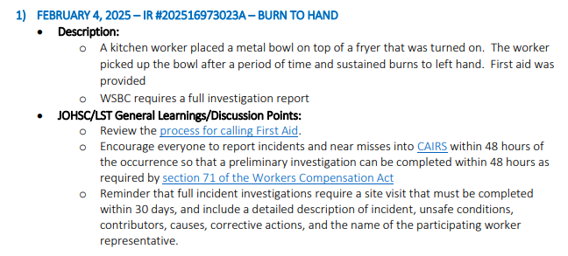
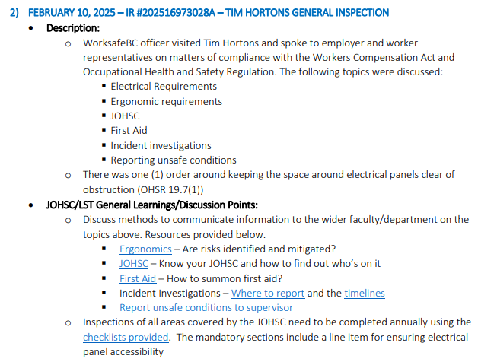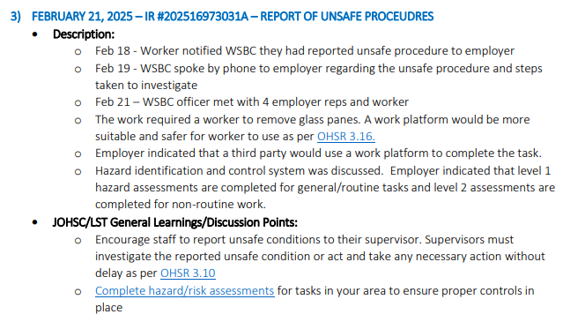

Sustainability Tips
#HowToGreenLab tip
Label energy-intensive equipment. Help your lab save energy by labeling energy-intensive equipment with reminders to turn it off when not in use. Start by identifying equipment such as biosafety cabinets, centrifuges, and spectrometers that consume high amounts of energy.
Add simple, clear instructions like “Turn Off When Not in Use” or “Shut Down Overnight” directly on the equipment. To make it engaging, consider using creative designs or mascots to make the labels more memorable.

- ONGOING BUSINESS – Status of Action Items (includes review of previous meeting minutes)
Items from JOHSC / RMS or other?
Original Item # | Priority | Action Plan  (Actions Taken/Need to be taken) | Assigned To | Follow up: Date Pending | Status
197 | C | Review field safety report and provide a summary. The program director should be approving the protocol instead of LST. Field work safety plan reminder should be sent out in January 2025. LF will send out the notifications faculty-wide. | LF | Sept 30, 2025 | IP
202 | C | A new item has been requested to capture all issues relating to MCML 214 transition to incoming PI.  - Door signage update  - Chemical inventory update  - Plant samples and pest controls  - Personnel working in MCML 214, work duties and projects, supervisor in LFS  - Type of hazards, health and safety controls, training records  A meeting is being set up with Gurcharn and his postdocs still in LFS to discuss about plans on sending samples to Alberta and vacating lab space. AJ will meet with GB and DK on Jan 17, 2025 to get clarity. Paul will take over MCML 214 effective Apr 1, 2025. Gurcharn’s staff will relocate to ZT lab for work in MCML 308. GB still has active appointment to supervise staff/students. | AJ | Mar 30, 2025 | IP
207 | C | Mouse poops still observed in MCML 148/144 and a big clean up will be necessary. There needs to be an organized clean up with users that frequently use the space. A meeting was scheduled on Nov 25 with all users of space to discuss about arrangement. A big cleanup has been done in the space in December 2024 but a space survey has been sent. Another meeting is scheduled to take place in late March 2025 to discuss. | LF/JE | Apr 30, 2025 | IP
210 | C | Why are soap and paper towels not provided broadly on campus? Or LFS? AJ will consult with the custodial group and building operations. UBC only provides soap and paper towels for common spaces and teaching spaces. Therefore, research labs will need to source their own supplies. | AJ | Mar 13, 2025 | C

- NEW & OTHER BUSINESS
Items from JOHSC / RMS or other?
Item # | Priority | Discussion and/or Action Items | Assigned To | Date to be Completed | Status
211 | C | Exhaust smell has been reported in office space MCML 270/278. Request for an air quality assessment by UBC. A request has been submitted on Apr 3, 2025. | IC | Apr 30, 2025 | N

- NEXT MEETING
Date: | Apr 25, 2025
Time: | 11:00 AM
Location | Remotely via Zoom or MCML 139

- MEETING ADJOURNED
Time: | 11:55 am

LEGEND

PRIORITY: |  | STATUS:
A | Critical/Life threatening/high probability | N | New
B | Urgent/moderate probability of re-occurrence | R | Repeat
C | Important/low probability of re-occurrence | C | Complete
D | Reminders | IP | In Progress
E | Information | RF | Referred forward

Send a copy of the meeting minutes report to the JOHSC. Highlight important items that must be reviewed/discussed at next JOHSC meeting.

Monthly Distribution and Posting of Approved Meeting Minutes (Required):
- All LST members
- Appropriate JOHSC
- Risk Management Service

