Local Safety Team Meeting Minutes

Name of Team: | MCML Local Safety Team | Chair(s): | Lewis Fausak

Date: | May 23, 2025 | Time: | 11:00 AM
Date: | May 23, 2025 | Location: | Remotely via Zoom

LAND ACKNOWLEDGMENT:
I would like to acknowledge that UBC’s Vancouver Point Grey campus is situated on the traditional, ancestral, unceded territory of the Musqueam people. I would also like to acknowledge that you are joining us today from many places, near and far, and acknowledge the traditional owners and caretakers of those lands.

AGENDA:
- Roll Call  - Review Central Accident/Incident Reporting System (CAIRS) report of Accidents/Incidents  - Monthly Incident List & Statistical Summary Report  - Review Workplace Safety Inspections (including any changes to equipment, machinery or work processes that may affect the health or safety of workers) | - Review Education and Training  - Ongoing Business – Status of Action Items, Review of Previous Minutes  - New and Other Business  - Next Meeting  - Meeting Adjournment

- ROLL CALL
Worker Representatives | Work Location | Present | Regrets | Absent
Imelda Cheung | MCML |  | ☐ | ☐
Alan Lee | MCML | ☐ | ☐
Sylvia Leung | MCML |  | ☐ | ☐
Carly McGregor | MCML |  | ☐ | ☐
Lewis Fausak | MCML |  | ☐ | ☐
Thorsten Knipfer | MCML | ☐ |  | ☐
Kylee Smith | MCML | ☐ | ☐
Samuel H. |  | ☐ | ☐ | ☐
Employer Representatives | Work Location | Present | Regrets | Absent
Andy Jeffries | MCML |  | ☐ | ☐
Resources/Guests | Work Location | Present | Regrets | Absent
Sylvia Nyamaizi | MCML |  | ☐ | ☐

Approve Previous Month’s Minutes? Yes No ☐

- REVIEW CAIRS REPORT OF ACCIDENTS/INCIDENTS:
See attached incident report:
Monthly Incident List & Statistical Summary Report (make note of trends etc. For any general CAIRS information that requires discussion or action, please record under “New Business”. Any incident specific items and follow up requests are to be listed below)
(* See Legend at end for Priority and Status Codes)
Item #  (Use CAIRS Incident ID #) | Priority | Date | Action Plan  (Actions Taken/Need to be taken) | Assigned To | Follow up: Date Pending | Status

- REVIEW OF WORKPLACE SAFETY INSPECTIONS (including any changes to equipment, machinery or work processes that may affect the health or safety of workers)
Inspections for April: None
Inspections for May: MCML 56, 59, 60, 62, 64, 66 (AJ)
Inspections for June: MCML 220, 230, 240 (IC), Office inspection building wide (AJ/IC/LF)
Item #  (Use Inspection #) | Priority | Discussion/Comments/Recommendations | Assigned To | Follow up: Date Pending | Status
MCML 62  H-11 | C | Lack of PPE observed in the space. It’ll be worthwhile to ensure aprons, oven mitts, pot coasters and food preparation gloves are available in the space. An email has been sent to lfsus. This space is actually assigned to Agora so will reach out to Agora. VCH inspection has noted PPE issues as well so AJ will confirm that this is addressed. | AJ/Agora | Apr 30, 2025 | IP
MCML 64  D-11 | C | Trophy and vases on top shelf pose falling hazard. Email lfs.facilities@ubc.ca to install an edge guard or lip on the top shelf to prevent items from falling. An email has been sent to lfsus. IC will inspect the space then email them for a workable solution to store trophies and vases. This item will close and a new inspection in June will address the issue if it still remains. | IC/LFSUS | May 13, 2025 | C
MCML 66  D-11 | C | Trophies are placed on top shelf, posing a falling hazard. Email lfs.facilities@ubc.ca to install an edge guard or lip to prevent items from falling. Email LFSUS executives to inquire whether they have better solutions for the trophies placement. Installing a lip guard is not sufficient to prevent the tall trophies from falling off in the event of an earthquake. This item will close and a new inspection in June will address the issue if it still remains. | AJ/LFSUS | May 13, 2025 | C
MCML 180G  H-6 | C | Top shelves have no lips or guards to prevent heavy totes from falling. Install a cable tie type of constraints or remove heavy totes from top shelves. Review inventory in space and dispose of materials that are dated and no longer needed. Move heavy totes to lower shelves if possible. LF and GC have worked in there and removed the heavy totes from top shelves. | LF/IC | May 23, 2025 | C
MCML 308  M-46 | C | Chemicals not segregated by hazard class, this is an ongoing task for the lab manager and LST. This lab stores a large variety of oxidizers; they either need to be stored in a secondary container or be in a separate storage area. This will require a large amount of time and will postpone till summer 2024. IC will email Peter K to initiate the process. Peter K acknowledged the email but did not give consent for us to work in the lab. AJ will talk to Andrew Riseman about lab activity in MCML 308. PK will not return to lab activity anymore and samples should be properly disposed of. New PI will look at the chemical inventory list to determine what to keep/discard before a proper segregation by hazard class will be performed. This item will likely not complete until summer 2025. The space will be allocated to new APBI hire – inventory and equipment list has been passed to the new PI (Zelalem Taye). The space has been recently tidied up and cleaned by LFS operations. ZT did not want any chemicals in the current space. IC will share the Quartzy inventory to AL and CM to see if they are interested in any. The rest of chemicals can be boxed up and stored until the summer for work learn to appropriately stock into general chemical rooms. Most chemicals have been removed and moved to MCML 220 for disposal. Therefore, this item can close. | LF/IC | May 23, 2025 | C
MCML 230  M-16 | C | There is a missing door on the shelf adjacent to MCML 230F containing glassware. Put items that are lighter in that shelf and move the glassware to a cabinet with a door. IC will reorganize and store only light items on the open shelf by May 31, 2025. IC has moved the glassware and now the open shelves only store filter papers which do not pose falling hazard. | IC | May 13, 2025 | C
MCML 140  D-11 | C | Heavy items at higher levels of the shelves (above eye level) need to be relocated to a lower area. Remove things that are no longer needed to make more available storage space, or move lighter things to higher spaces and heavier things to lower spaces. LF has moved heavy items lower so this is complete. | IC/LF | May 23, 2025 | C
MCML 302, 329, 248  D-4 | C | There are no blinds in the lab. Install blinds. Combine in one item. LF has to measure the dimensions of windows in MCML 302 and install own blinds potentially. Lab space is the responsibility of the PI so this item is closed. | LF | May 23, 2025 | C
MCML 190E  D-1 | C | Window bar is disconnected from the window. The window is unable to close or open. Repair the window bar, reconnect it to the window. Unfortunately, the window bar was no longer manufactured. Therefore, we will have to wait for decommissioned building to retrieve functional window bar for replacement. This could take some time. Submit a request to get the bar adjusted. | AJ/LF | Apr 30, 2025 | IP
MCML 140  D-5 | C | There is a loud repeating noise coming from the air duct. Inspect the air duct to see what is causing the noise and see if it can be resolved without compromising the air duct. A request has been submitted. Building ops has come to inspect and noise is no longer heard. This item is closed. | AJ/LF | May 23, 2025 | C
MCML 248A  D-10 | C | There is a wooden cabinet that is not attached to the wall. Attach the cabinet to the wall with anchors or other means. The cabinet has been moved and is no longer an issue. This item can close. | AJ | May 23, 2025 | C
MCML 254  D-10 | C | The cabinets are not attached to the wall. Attach the cabinet to the wall with anchors/hooks. LF will submit a service request to get anchored. The cabinet is anchored so this item can close. | AJ/LF | May 23, 2025 | C
MCML 264, 264A  D-5 | C | There is a rattling noise coming from the air ducts. Inspect the air ducts and see if the noise can be resolved without compromising the function of the air ducts. A request has been submitted. An issue is located and the loose damper has been fixed. This item can close. | LF | May 23, 2025 | C
MCML 194  M-23 | B | Roller shades on the West window are not operational, this room needs properly functioning shades due to a two way mirror that enables researchers to view subjects. LF to submit a request to have roller shades fixed. The roller shades should still be under warranty by Cascadia. | LF | May 31, 2025 | IP
MCML 22A  F-34 | C | Some items placed near the door make accessing the light switch difficult. Suggest to relocate these items and clear area. | AJ/LF | May 31, 2025 | IP
MCML 48D,G,H  H-20 | C | Storage areas are cluttered – suggest to clear out so that lights are accessible | AJ/IC | May 31, 2025 | IP
MCML 48A  F-34 | C | Paint shaker ball mill foam has fallen off. Not sure if we want to screw it in instead of duct taping? It might not go back in as it is mildly shredded. Look for foam panel to replace in workshop. LF found screws and nuts to secure. SN/LF/AJ will meet to look at the other large shaker to see if it will be appropriate for the research work. | AJ/LF | Apr 30, 2025 | IP
MCML interior  B-16 | A | Doors will not close at 166 classroom; doors always propped open near 166 hallway. Submit a service request to have the doors inspected and fixed. The door is since fixed and the item can close. | LF | May 23, 2025 | C
MCML 66  D-1 | C | Blinds are fully open during inspection. Email LFSUS executives to ensure blinds are closed daily upon exits to prevent potential thefts in the space due to the widely open view of the space. This will be done in conjunction with the upcoming annual inspection to the new LFSUS executive members. | IC | Jun 30, 2025 | IP
MCML 214  M-14 | C | Biohazard wastes observed in space but space does not have a biosafety permit and door signage does not reflect biohazard level 1 work. Space is being decommissioned; biohazard materials should be properly disposed of before passing the space to another PI. | IC | May 31, 2025 | IP
MCML 214  M-16 | C | Some glassware are stored on the wooden shelf and poses falling hazard. Relocate them to another space and store only light items (e.g. paper towels, plastic beakers, etc.). Most items have been removed so this item can close. | IC | May 23, 2025 | C
MCML 214  M19/20 | C | Students and researchers working in the space either do not have their profile added to TRMS or they have incomplete training records. Email Sam H. to ensure these workers have their training records in TRMS to meet UBC safety requirements. The space has been vacated and assigned to a new PI. Email and notify the PI of the proper process. This item can close. | IC | May 23, 2025 | C
MCML 214  M-23 | C | Lights are out at the corner of MCML 214, in 214A and in 214B. Submit a service request to replace lights. This is complete. | LF | May 23, 2025 | C
MCML 214  M-39 | C | No biosafety permit is posted. Biosafety work should have completed but biohazardous wastes have to be properly disposed of. Consult with the new PI to see if any permit process should be initiated. Consider a PI onboarding package from the lab safety point of view including biosafety permits, Quartzy use, hazardous waste management, etc. | IC | May 31, 2025 | IP
MCML 218  M-16 | C | Two metal shelving by wall are not anchored. Zip-tied the two shelving together so as to reduce chance of shelves tipping over.  The large shelving is fully packed with materials and some boxes contain glassware on top shelf. Recommend to move heavy and glassware boxes to lower shelves to prevent falling hazard. The space is in the process of reorganization so hopefully some of these issues will be addressed soon. | IC | Jun 30, 2025 | IP
MCML 218  M-24 | C | Many totes are stacked 5 boxes high; they’re quite stable and not difficult to fall. Best to only stack 3 boxes high; the samples are being arranged to be shipped out so the issues may resolve soon. Majority of the totes have been emptied and contents trashed. Remaining totes will be shipped out by end of June 2025. | IC | Jun 30, 2025 | IP
MCML 218  M-28 | C | Ergonomic posters are not found. Put up few posters to encourage users to pay attention to ergonomics. | IC | May 31, 2025 | IP
* GI- General Inspection

- EDUCATION AND TRAINING

Recommended items to discuss at JOHSC/LST Meeting (April, May)
Safety Day 2025 – Save the Date
Safety Day 2025 will be held on Wednesday October 8, 2025. Please save the date. Agenda and Registration will be released in the upcoming months once finalized.

New tool to support managers with ‘offer of modified duties’ to injured workers
When a worker is injured, WorkSafeBC legislation requires employers to offer safe, suitable modified duties as soon as possible. To help managers fulfill their obligations, a new Tip Sheet for Offering Modified Duties is available on the HR website and attached for reference. This can be used:
- Day of injury, after First Aid assessment (minor injuries)
- Before the next scheduled shift (minor injuries)

Managers should document any modified duties discussed with the worker in CAIRS or by emailing UBC’s WSBC Claims Associate at wcb.info@ubc.ca.
- Learn more about WorkSafeBC’s Bill 41: Duty to Cooperate and Duty to Maintain Employment
- See UBC’s Manager's Guide for WorkSafeBC Claims (CWL login required)
- Contact UBC’s WSBC Claims Associate at wcb.info@ubc.ca for support with any of the above

Musculoskeletal Injuries
UBC’s very own Student Housing and Community Services Unit has been featured in WorkSafeBC Enews highlighting their great work around managing the risk of musculoskeletal injuries (MSIs). Read more using the link provided.

MSI is an injury or disorder of the muscles, tendons, ligaments, joints, nerves, blood vessles or related soft tissue including sprain, strain and inflammation that may be caused or aggravated by work. MSIs make up approximately 30% of WorkSafeBC injury claims at UBC.
- To prevent such an injury, review and implement the information provided on the Ergonomics website and contact ergnomoics.info@ubc.ca as needed for additional support
- If anyone in your areas has suffered an MSI injury, there are UBC resources to assist with investigating these types of incidents. Please share these widely with your areas.

Building Emergency Response Plan (BERP)
The 2025 BERP template has been updated and accompanied by a list of changes. Please remember to annually review the BERP for your building and distribute a final copy to all the building occupants. Please email completed copies of the BERP to safety.risk@ubc.ca, with any individualized evacuation plans removed prior to submission.

Remember to schedule an annual fire drill once within a calendar year! Instructions on how to schedule a drill is included in the BERP along with guidance on what to do for disability and accessibility considerations.

Amendments to the Occupational Health and Safety Regulation — Part 16, Mobile Equipment, Three-Point Seat Belts
WorkSafeBC has approved amendments to Part 16 of the Occupational Health and Safety Regulation related to seat belt requirements on mobile equipment.

Effective March 31, 2025, updates to sections 16.21 and 16.21.1 clarify when a minimum 3-point seat belt is required on Roll Over Protective Structure (ROPS) equipped prime movers. These changes aim to improve operator protection in rollover scenarios, particularly in higher-risk environments such as forestry, wildfire response, and steep-slope land clearing.

If your area purchases or oversees ROPS-equipped mobile equipment (e.g., haul trucks, forestry or land clearing machines), ensure that any equipment manufactured on or after March 31, 2027 is specified or ordered with a minimum 3-point seat belt to comply with the updated regulation.

Please see the attached document for the full approved amendments.

Emergency Preparedness Week
Emergency Preparedness Week (EP Week) is May 4 to 10 in 2025 and is a great time to learn about getting prepared for emergencies. Prepared BC will be hosting a series of webinars on:
- Inclusive Preparedness | May 5
- Cultural safety & preparedness | May 6
- Animal preparedness | May 7
- Insurance: why it matters | May 8th
- In it together: community preparedness |May 9th

To register for a webinar, click here. Additional information on Emergency Preparedness Week from Prepared BC is available on their website.

To learn more about Emergency Management at UBC, visit our website Emergency Management | Safety & Risk Services

Informational Items

Day of Mourning
Across Canada, April 28 has been designated as the Day of Mourning. It is a day to remember those who have lost their lives to work related incidents or occupational disease and to renew our commitment to creating healthy and safe workplaces. A list of BC Ceremonies is provided on the link above.

JOHSC Training
Currently, there are no sessions scheduled for Part 2 of either the JOHSC or LST training as Shilan Keshvadi will soon be leaving the University. Thank you Shilan for all your contributions and for supporting the JOHSCs and LSTs over the years!
You can register for JOHSC training part 1 here, and LST training part 1 here.

WorkSafeBC Inspection Reports (IR)
There were 4 WorkSafeBC Inspection Reports received since the March co-chair email. As always, the “WSBC IR Summary” attachment provides a brief summary for the inspection reports and some discussion points to consider.
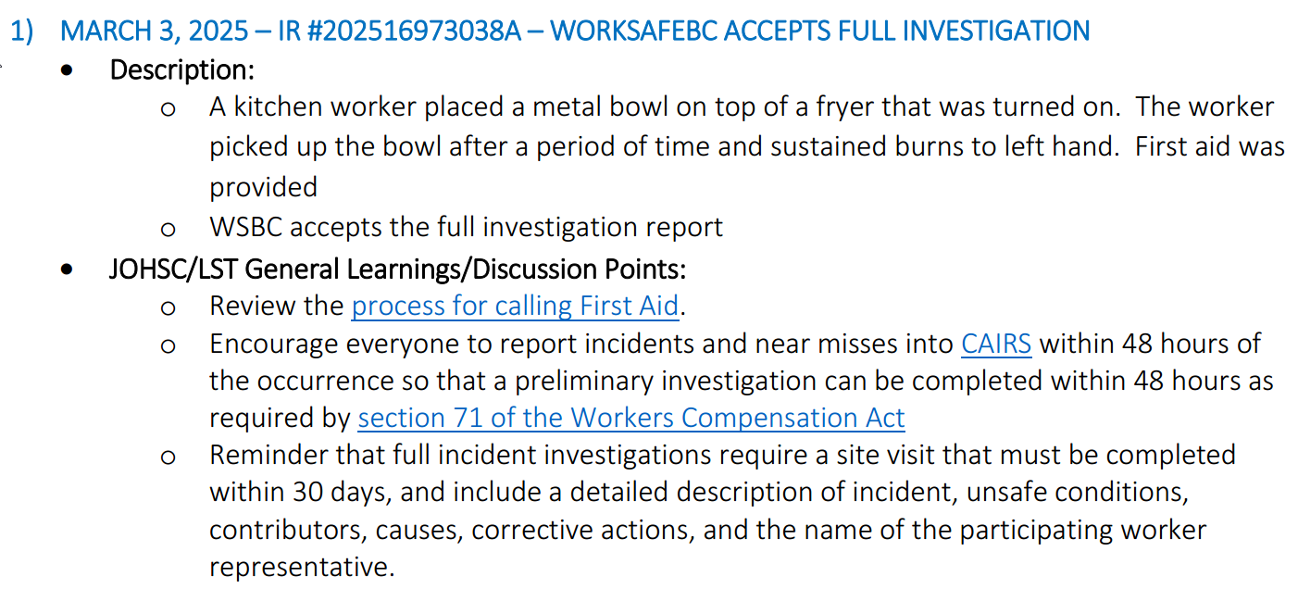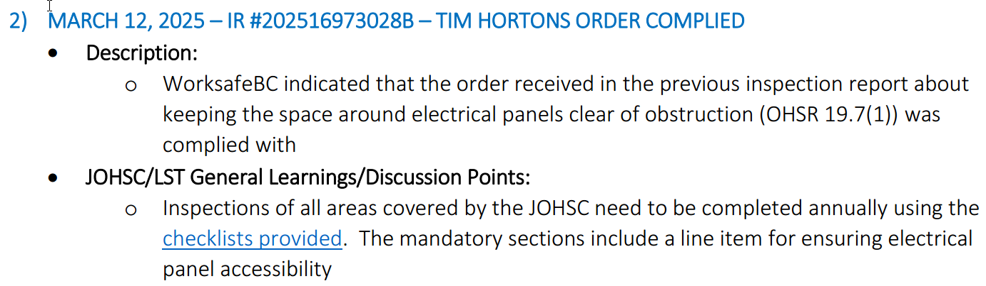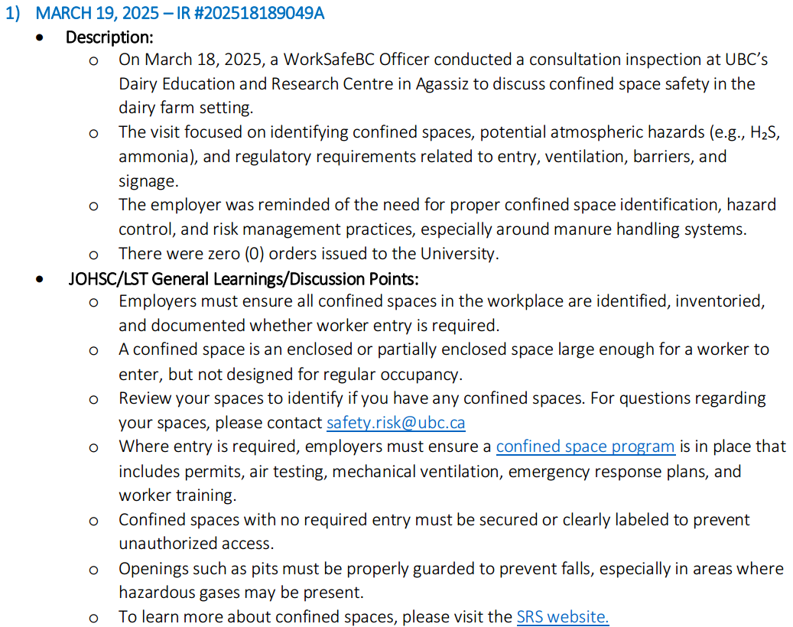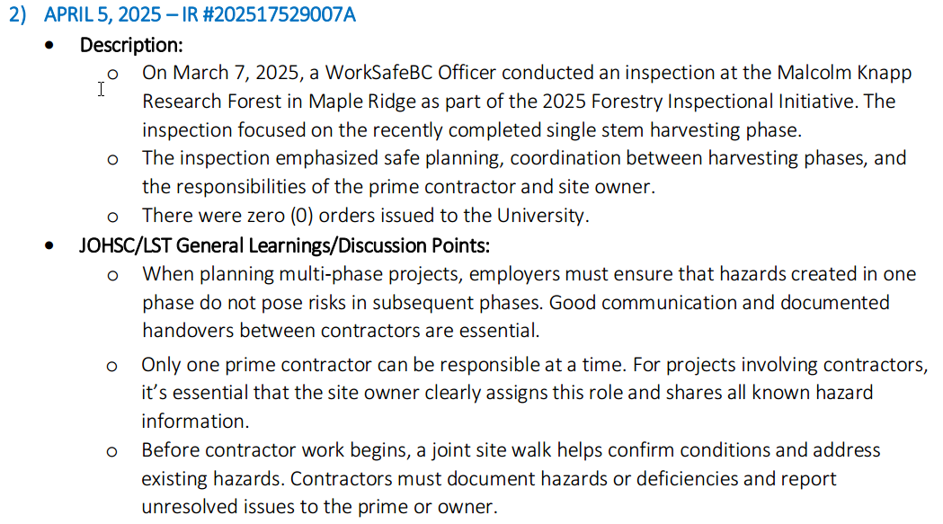
Sustainability Tips
#HowToGreenLab tip
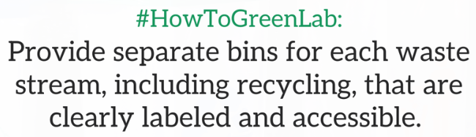

- ONGOING BUSINESS – Status of Action Items (includes review of previous meeting minutes)
Items from JOHSC / RMS or other?
Original Item # | Priority | Action Plan  (Actions Taken/Need to be taken) | Assigned To | Follow up: Date Pending | Status
197 | C | Review field safety report and provide a summary. The program director should be approving the protocol instead of LST. Field work safety plan reminder should be sent out in January 2025. LF will send out the notifications faculty-wide. The approval by program director has been turned down within LFS so PI should work with each other to come up with the plan. Since posting in LFS Today, more safety plans have been submitted for review. | LF | Sept 30, 2025 | IP
202 | C | A new item has been requested to capture all issues relating to MCML 214 transition to incoming PI.  - Door signage update  - Chemical inventory update  - Plant samples and pest controls  - Personnel working in MCML 214, work duties and projects, supervisor in LFS  - Type of hazards, health and safety controls, training records  A meeting is being set up with Gurcharn and his postdocs still in LFS to discuss about plans on sending samples to Alberta and vacating lab space. AJ will meet with GB and DK on Jan 17, 2025 to get clarity. Paul will take over MCML 214 effective Apr 1, 2025. Gurcharn’s staff will relocate to ZT lab for work in MCML 308. GB still has active appointment to supervise staff/students. MCML 214 is now officially Paul’s lab. | AJ | May 23, 2025 | C
207 | C | Mouse poops still observed in MCML 148/144 and a big clean up will be necessary. There needs to be an organized clean up with users that frequently use the space. A meeting was scheduled on Nov 25 with all users of space to discuss about arrangement. A big cleanup has been done in the space in December 2024 but a space survey has been sent. Another meeting is scheduled to take place in late March 2025 to discuss. A cleanup has been done and no further trace has been observed. | LF/JE | May 23, 2025 | C
211 | C | Exhaust smell has been reported in office space MCML 270/278. Request for an air quality assessment by UBC. A request has been submitted on Apr 3, 2025. A visit has been performed together with SRS and senior facilities manager on Apr 17th. It is suspected that the engineering group may be working in the workshop and the smell may have come in through the windows. Office occupants were told to notify Andy J/SRS immediately to inspect on the spot. | IC | May 23, 2025 | C
- NEW & OTHER BUSINESS
Items from JOHSC / RMS or other?
Item # | Priority | Discussion and/or Action Items | Assigned To | Date to be Completed | Status
212 | C | Review new term of reference for 2025. It will be posted on intranet for record. | IC | May 31, 2025 | C
213 | C | Recommend to meet less frequently during summer due to lower activities. Special meeting can be called if needed. Proposed next MCML LST meeting time to be July 11, 2025. | IC | May 31, 2025 | C
214 | C | Update MCML BERP for review. | IC | May 31, 2025 | N
215 | C | Schedule for a fire drill. Proposed dates: Jun 10th, Jun 17th, July 8th, July 29th, Aug 26th | IC | May 31, 2025 | N
216 | C | Identify the potential confined space in MCML and come up with a plan for it. | AJ/LF/IC | Jun 30, 2025 | N
217 | C | Violence Prevention Form for public facing units like Agora, Student Services and Dean’s office. | AJ/LF/IC | Jun 30, 2025 | N
218

- NEXT MEETING
Date: | July 11, 2025
Time: | 11:00 AM
Location | Remotely via Zoom or MCML 139

- MEETING ADJOURNED
Time: | 12:11 am

LEGEND

PRIORITY: |  | STATUS:
A | Critical/Life threatening/high probability | N | New
B | Urgent/moderate probability of re-occurrence | R | Repeat
C | Important/low probability of re-occurrence | C | Complete
D | Reminders | IP | In Progress
E | Information | RF | Referred forward

Send a copy of the meeting minutes report to the JOHSC. Highlight important items that must be reviewed/discussed at next JOHSC meeting.

Monthly Distribution and Posting of Approved Meeting Minutes (Required):
- All LST members
- Appropriate JOHSC
- Risk Management Service

